PEEP model phrases – from textbook on page 32
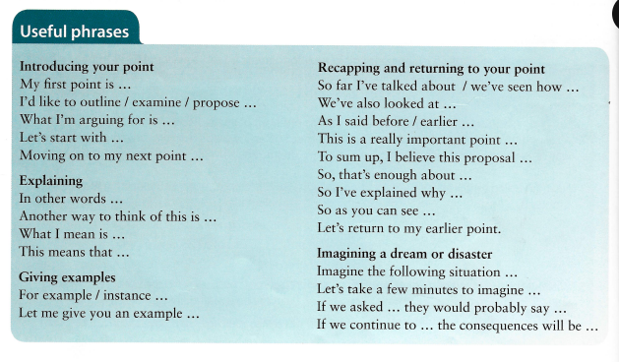
Describing visual aids – phrases from textbook on page 32

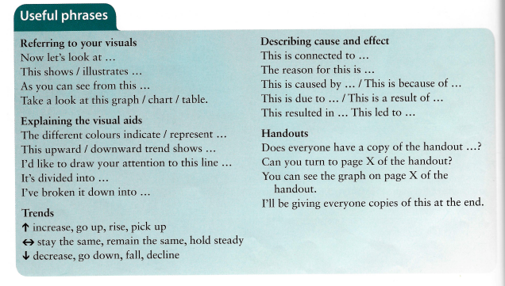

Useful phrases to describe graphs, charts, …
