Using PowerPoint
1. Reduce text to the minimum
If there is the option to use an image instead of text, choose an image. Text does not help learning in a presentation, it forces the audience to choose between reading or listening, which usually results in the audience doing neither very well. Visuals remain with the audience without hindering the audience’s ability to listen. Therefore, it is advisable to use the minimum amount of text, think keywords rather than sentences and paragraphs. Do not put hard-to-read charts with masses of data on slides. If you have information that is data-heavy and you wish to share it, provide handouts after the presentation.
2. Bullet points, keywords, one idea per slide
Bullet points are a great way to summarize your data; however, slides should not function as a teleprompter, and too many of them are a chore to read. Present the information you want to share within your message, do not put it on the slide. If necessary, you use a keyword to fix a point in the audience’s mind.
The more bullet points you have on a slide the less of an impact they make, therefore using one bullet point per side is ideal. Again, consider using keywords and phrases rather than bullet points. The aim of presenting is for the audience to retain the information you give them. Using one slide per point ensures that the audience has the best opportunity to retain the information.
Specific numbers or data that is important can be put onto slides by themselves. The audience is unlikely to remember more than one or two figures from the presentation, so make sure that you give them only the most important ones. However, the presenter should know all the data and be able to answer questions about it.
3. Avoid animation distraction
Too many different animations can make your presentation look like a child’s 5th-grade project rather than a smooth professional presentation. Choose one type of animation for use throughout the presentation, this should generally be clear, simple, and non-distracting. Sound effects should not be used without great cause to do so.
4. Quality photographs and video
Use quality photographs. Sharp, professional photographs create a much better effect than low-quality photographs or clip art and can lift the feel of your presentation. One good picture is worth a thousand words and can remain in your audience’s mind long after your presentation; however, the photograph must support your presentation (presentation - not art gallery). In addition, PowerPoint allows the embedding of videos into presentations, which can be ideal for show real examples and demonstrations. However, videos should be used with caution and systems checked to ensure their smooth running beforehand. If there is any doubt over the playing of the video or quality, it should be removed, and an alternative found.

5. Personal style
PowerPoint comes with a range of standard templates, which are very useful; however, it looks very bad if you are using the same template as the previous presenter. Consider using a template that you have personalized yourself if you want your presentation to stand out from the crowd.
6. Data display
Data should be clearly displayed and easy to understand, which generally means displaying only the most important figures (although, you should know your data well and be prepared to be questioned about it). Graphs and charts are a useful way of displaying data, but they should be clear and not misleading (be careful with three-D charts which can be misleading and difficult to read). The number of items displayed on a graph or chart should be kept to about five items of data, the more data is added the more difficult it is to read and less will be retained. Eye-catching colours create a good impact. Limit the text on graphs and charts to the title and axes. The text should be in a clear easy to read size and font.
7. Refine
Refine your slides with a critical eye. Consider what your audience will get from each slide, does it help them to understand your presentation? Does it fix your presentation in their minds? More importantly, does my audience even need this slide, or is it just a distraction?
A good exercise to find out how useful your slides are is to display your presentation on a laptop or computer at your side and ask a friend or peer to watch your presentation. The audience has to choose where their attention is directed, therefore, it highlights which slides are useful and which are not.

Look at the following slides, write down the issues with each slide and suggest how you would improve them.

A presentation explaining the workings of an engine part to a group of potential investors.
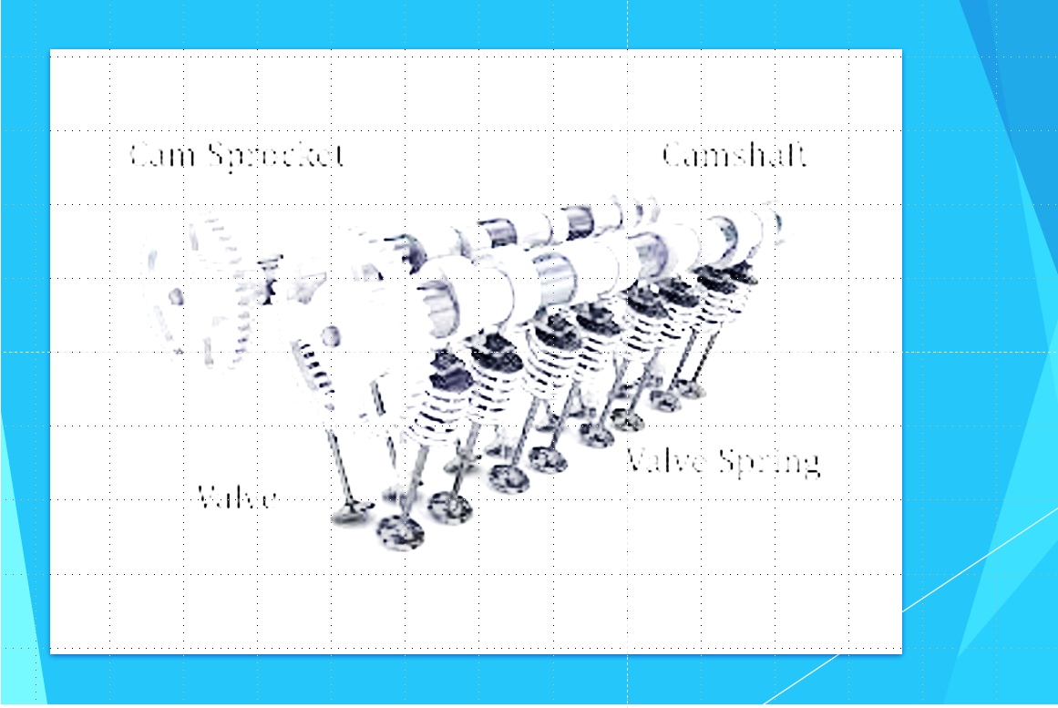
Issues and Suggestions
The photograph and labels are unclear and should be replace with a professional looking high quality photograph which is clearly labelled.

Presentation to an American company thinking of producing and selling high quality spirits in Northern Europe.
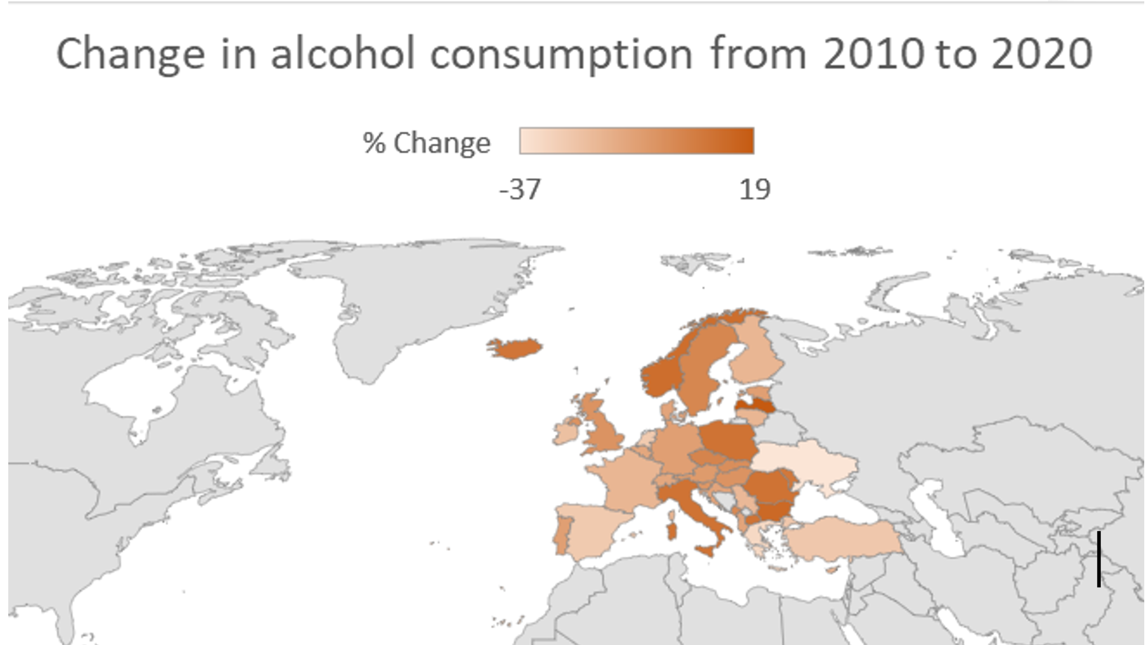

Issues and Suggestions
The picture is not labelled, which would cause some problems for an American audience whose familiarity with European geography may not be strong. Also, it is difficult to see the changes in alcohol consumption – there are only two numbers on the scale, and it is not clear which shade of brown represents an increase, decline, or no change in consumption.
A simple bar chart representing the desired geographical area (Northern Europe) would be better. A separate, bold colour for each country with clearly labelled axes.

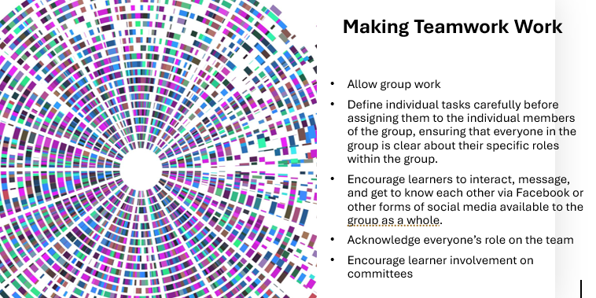
The following 2 slides are from a presentation on training millennials.

Issues and Suggestions
Too much text is on the slide. Replace the text with 5 keywords or phrases in size 30 font. The large graphic on the left could be replace with something more relevant to the topic.

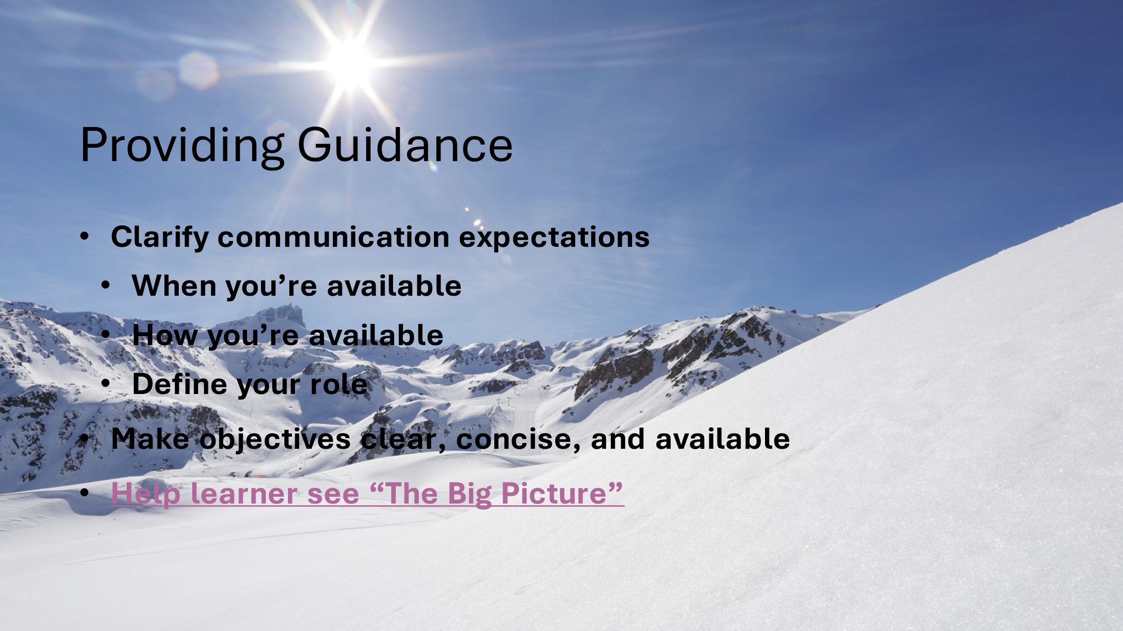
Audience applause sound effect on click.
Issues and Suggestions
Bullet points are obscured by the background picture. Decide if the bullet points are necessary, if not remove them. If the bullet points are necessary, redesign the slide to remove the background photo and replace with a more relevant photograph to one side of the slide. The font size should be increased to size 30 font and the audience applause sound effect should be removed.

