The concept of digital pitch-type presentations (Digital P-T-P)
Digital pitch-type-presentation
The digital pitch-type presentation was first explained to me by first considering the American system of submitting cases to the American Supreme Court. When a case is submitted to the Supreme Court many hours of work and preparation have gone into the case, but for the initial submission, it all has to be distilled down into one single A4 page. A single A4 page that gives the essence of the case but at the same time is still very persuasive. This is the quiddity of the digital pitch-type-presentation.
A digital pitch-type-presentation is a form of online presentation that takes the best elements from both a pitch presentation and a traditional presentation. From the pitch presentation, it takes the brevity of the pitch, trying to communicate as much as possible, in as short a period of time as possible. From the traditional presentation, it takes the broadness of the range of topics and depth of research. The digital pitch-type–presentation then combines these elements with an interactive question and answer session, which leads the digital pitch-type-presentation into a professional discussion.
Distillation of ideas
Digital P-T-P
All finished within 15 minutes
Interactive professional discussion
Digital presentation
If we think of the Digital P-T-P as a triangle, it starts with broad input from the lecturer on a subject (such as management). The student leaves the lecture, thinks about the subject, and expands upon it, leading to further ideas related to the original subject. After a period of thought and reflection, the student refines these ideas into a new approach to the topic, which the student then takes to the lecturer as an idea for a Digital P-T-P (How to manage generation Y?). The lecturer helps the student to condense these ideas into the most important points (be a leader, theory Y approach, create the right conditions for workers) and to finally fit them into a 3-5 minute Digital P-T-P.
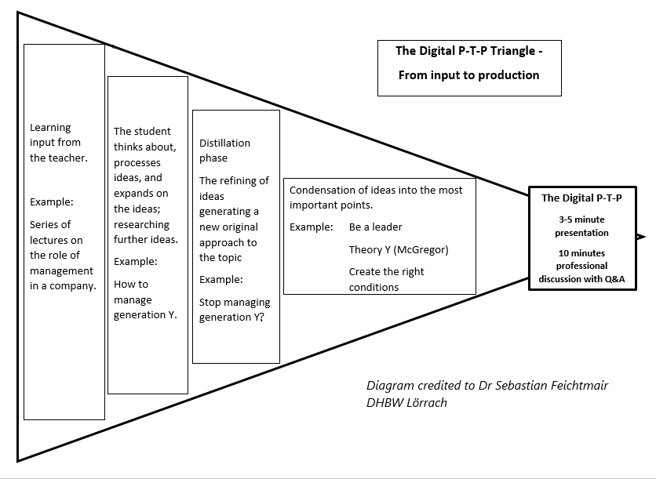

Task 1 - MCQ

- A Digital P-T-P should be ________________________

- 3-5 minutes
- 5-7 minutes
- as long as necessary

- A Digital P-T-P requires ________________________

- a lot of research by the student
- a large number of PowerPoint slides
- detailed graphs and tables

- A Digital P-T-P should present ________________________

- the most important points
- lots of additional background material
- only requests for investment

- The student should ________________________

- do a lot of research into their chosen topic.
- rely on their teacher for all information.
- stick to tried and tested approaches to the topic.

Task 2 Put the following into the correct order

1 | Learning input from the teacher
2 | The student thinks about the topic, process ideas, and expands on the original topic researching further ideas.
3 | The student refines the ideas into a new original approach.
4 | Condensation of the ideas into the most important points
5 | The Digital P-T-P

Learning Outcomes
By the end of the course, the student should be able to -
- use and explain the key terminology, concepts and models related to the field of the course,
- recognise problems or challenges related to the main issues of the course,
- recommend solutions of their own to business-related problems,
- propose a way to address such challenges with proper reasoning,
- discuss the problem and its factors, and argue for their recommended solution during a conversation with an expert of the field, delegated by the companies,
- demonstrate the above knowledge and skills in a digital environment.

Task 1 - Which of the following are not learning outcomes of the course
By the end of the course students should be able to-
A | create complex sides on Microsoft PowerPoint using advance animation techniques
B | write an argumentative essay of 500 words justifying the solution put forward in the Digital P-T-P
C | use and explain the key terminology, concepts and models related to the field of the course,
D | recognise problems or challenges related to the main issues of the course,
E | recommend solutions of their own to business-related problems,
F | propose a way to address such challenges with proper reasoning,
G | discuss the problem and its factors, and argue for their recommended solution during a conversation with an expert of the field, delegated by the companies,
H | demonstrate the above knowledge and skills in a digital environment.

