**Task 5**

Create a savings calculator according to the pattern.





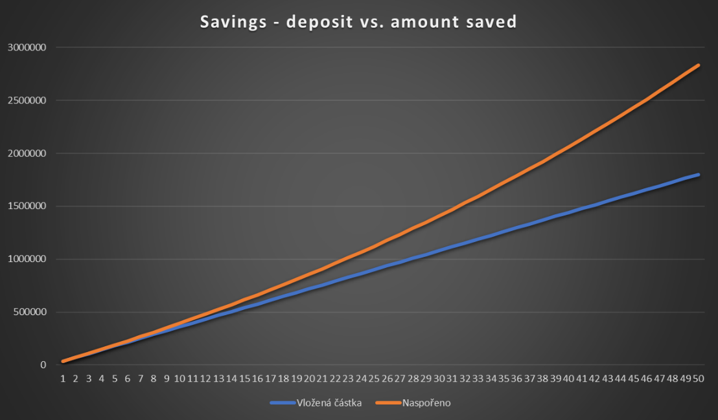

**Tasks:**

**1.** For "Monthly Deposit", use the control to set the option to select a value between 100 and 30,000. The incremental value will be 100.

**2.** In the "Lenght of saving (years)" line, use the control to set the option to select a value between 1 and 50. The incremental value will be 1.

**3.** For "Interest rate (%)", create an automatic percentage calculation with a decimal incremental price.

**4.** In the "Amount invested" line, set the amount to be expressed automatically based on the "Monthly deposit" and "Savings duration".

**5.** For "Interest rate", create an automatic value calculation.

**6.** In the "Total saved (excluding interest tax)" line, use the FV (FVSCHEDULE) function to set this amount to be expressed automatically.

**7.** For the item "Total saved (with tax)", use the FV (FVSCHEDULE) function to set the automatic expression of this amount.

**8.** Create an automatic statement of this item in the "Interest rate tax" line.

**9.** Based on the values ​​obtained, create a table that will contain rows entitled "Number of years", "Deposited amount", "Saved", "Monthly deposit", "Interest rate" (set the values ​​automatically for each item).

**10.** Create a dynamic chart whose values ​​will be automatically adjusted according to the changes in both tables.