Worksheet number 8 – Franchising

Task 1: Read the text and answer the questions below:
Franchises Moving into Diversity Challenge
Taco Bell, an iconic Mexican-style fast-food chain with locations across the globe, is starting a Taco Bell Business School in 2022—a six-week boot camp to teach future managers and franchisee owners the ins and outs of fast-food management and to increase diversity among Taco Bell franchisees. The initiative started when Taco Bell's parent company Yum! Brands created the Yum! Center for Global Franchise Excellence, which partnered with the University of Louisville in 2021. "Franchising is one of the best paths to entrepreneurship, creating an opportunity to build generational wealth," said Kathleen Gosser, PhD, executive-in-residence at the University of Louisville College of Business. However, this approach to become an entrepreneur and carve an independent financial path is rarely taken by people of color and women, which is what Taco Bell is hoping to change. "Our goal is to uncover and reduce barriers to franchise ownership, starting with education," explained Gosser. Participants will receive accredited training with classes ranging from finances to human resources, marketing, and entrepreneurship.
Another franchise giant, McDonald's, is going even further to address the diversity in the franchise community, believing that limiting its focus on nurturing an inclusive environment to just one time will not create a permanent change. McDonald's believes that cultures need to be nurtured on an ongoing basis, which is why they put together a long-term investment to address its multipronged Diversity, Equity, and Inclusion Initiative announced in 2020. Ninety-three percent of McDonald's restaurants are owned and operated by franchisees, making them a crucial part of McDonald's business that serves diverse and vibrant communities all over the world. Yet franchisee owners do not currently reflect that same diversity. Indeed, starting a franchise is often a great financial burden. McDonald's found that up-front entry costs are a barrier for many entrepreneurs with limited access to capital, especially for entrepreneurs from historically underrepresented groups. The company committed $250 million over five years to provide alternative financing options in the hopes of tackling this challenge.
Besides tackling the barriers to entry into franchise owner- ship, McDonald's is also significantly expanding its recruiting and training efforts and implementing a mentorship program from experienced owners for new franchisees. This increased interconnectedness should facilitate knowledge sharing and improve the chances of success for all franchisees with the ambition of running their own McDonald’s business regard- less of their background. It is not enough to just enable more underrepresented groups to enter into franchise community; it is equally important to support them in the running of their business, as they may not by themselves have access to this type of network and knowledge, which can be crucial for the success of a business.
What is even more significant is that McDonald’s is tack- ling diversity challenges throughout its value chain. The company has committed to a 10 percent increase in spending with underrepresented suppliers, which will bring the total number to $3.5 billion in annual spending by 2025. In marketing, it aims to increase its marketing spending with diverse-owned media from 4 to 10 percent and with Black-owned media from 2 to 5 percent of the total national advertising budget by 2024. McDonald’s is also tackling diverse representation in leadership roles by linking these targets to executive compensation. Finally, with the implementation of the new Global Brand Standards in all 40,000 restaurants and corporate offices around the world, it seeks to further a culture of physical and psychological safety through the prevention of violence, harassment, and discrimination.
It is certainly exciting to see big franchise names get on board with diversity, equity, and inclusion in a more meaningful way. They need to take ownership of the diversity issue and take proactive steps in order to make an impactful difference. To do nothing equals contributing to the existing problem that has, throughout history, become ingrained into our daily lives and that will require a systemic change. Only time will tell how effective these initiatives will be in truly diversifying the franchise community.
Source: Adapted from Michael Gonda, "What McDonald's Is Doing to Promote Minority-Owned Franchisees," Inc., January 2022, and "The Real Reason Taco Bell Just Launched Its Own Business School," Mashed, January 2022.

- What is meant by the term franchise?
- What are some of the major advanteges of franchising? Cite and explain two.
- What are some of the major disadvanteges of franchising? Cite and explain two.
- How can a prospective franchisee evaluate a franchise opportunity? Explain.
- What specific steps is McDonald's taking, in addition to financial support, to improve diversity within its franchise community?
- What are the key challenges and opportunities for large franchise companies, according to the author of the text?

Task 2: Identify the Franchise Disclosure Document. Explain why it is important in franchising:
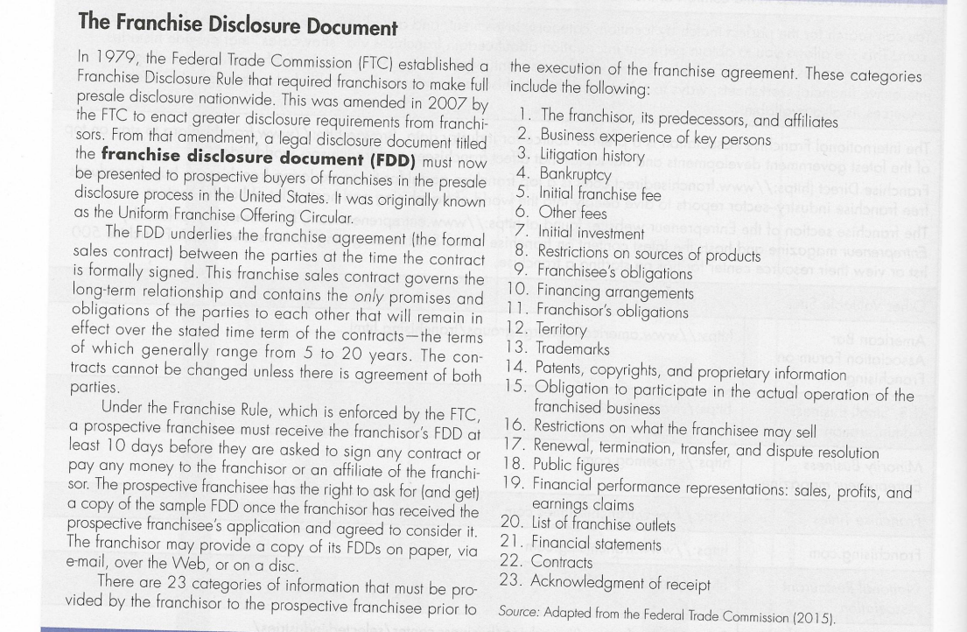
Task 3:
Describe the Marriott International/ Starbucks/ Subway company, which uses a franchising model, and find out:
- What is its area of focus?

- What is the company's history?

- In which markets does it operate and in how many countries can Marriott International/ Starbucks/ Subway be found?

- How many branches does it have in total?"

