# Worksheet number 6. - Legal Forms and Fare Trade

**Task 1. Match each legal business structure to its correct characteristic:**

Sole proprietorships, Limited Partnerships, Limited Liability Companies (LLCs), L3C (Low-profit Limited Liability Company), Limited Liability Partnerships (LLPs), Partnerships, B Corporations (B-Corps), Corporations, S Corporations (S-Corps)

1. This is the simplest business structure, where one individual owns and operates the business. The owner has complete control over the business and receives all profits, but also bears all losses. The owner is personally liable for all business debts.
2. This structure involves two or more individuals who own and operate the business together. Partners share profits, losses, and responsibilities according to their agreement. There are various types, including general partnerships and limited partnerships.
3. This is a legal entity separate from its owners (shareholders). Shareholders have limited liability, meaning their personal assets are protected from business debts. The corporation is governed by a board of directors.
4. This structure combines elements of partnerships and corporations. It includes general partners (with unlimited liability) and limited partners (with limited liability). General partners manage the business, while limited partners contribute capital.
5. Similar to partnerships but provides limited liability for its partners. Often used by professionals like lawyers and accountants. Partners personal assets are protected.
6. This is a specific type of corporation that allows pass-through taxation. Profits and losses are passed through to the shareholders' personal income tax returns. It has restrictions on the number of shareholders.
7. This structure combines the limited liability of a corporation with the flexibility of a partnership. Owners (members) are not personally liable for the company's debts. It has fewer formal requirements than a corporation.
8. This is a corporation that has committed to social and environmental goals in addition to financial profits. It must meet rigorous standards of social and environmental performance.
9. This is a hybrid of a LLC that combines profit generation with socially beneficial purposes. Designed for social enterprises seeking investment.

**Task 2.**

Within the European Union, there are also legal structures for businesses. These structures include: the Societas Europaea (European Company), the Societas Cooperativa Europaea (European Cooperative Society) and European Economic Interest Grouping.

**Focus on Societas Europaea (European Company) and:**

Describe the company:

Basic conditions for its establishment are:

Summarize the advantages:

Choose one European Company and characterize it (in which countries it operates, what is its area of ​​interest):

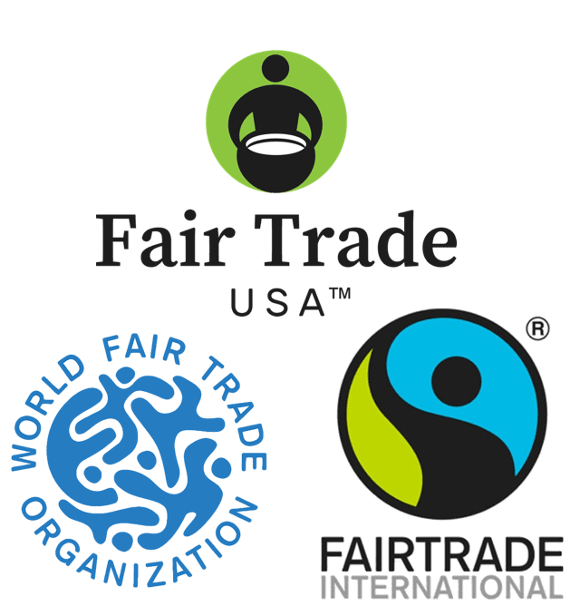

**Task 3.**

**What is Fair Trade**

Fair trade traces its roots to 1946 when Edna Ruth Byler, a volunteer for Mennonite Central Committee (MCC), visited an MCC sewing class in Puerto Rico where she witnessed the talent the women had for creating beautiful lace and the poverty in which they lived despite their hard work. She began carrying these pieces back to the United States to sell and returning the money back to these groups directly. Her work grew into [Ten Thousand Villages](http://www.tenthousandvillages.com/), which opened its first fair trade shop in 1958 and is now the largest fair trade retailer in North America. In 1949, Sales Exchange for Refugee Rehabilitation and Vocation (Serrv) began helping refugees in Europe recover from World War II. Today, they support artisans in more than 35 countries.

In the late 1970s and early 1980s, US- and Canadian-based entrepreneurs who defined their businesses with the producers at heart began to meet regularly, exchange ideas, and network. This informal group, known as the North American Alternative Trade Organization (NAATO) would evolve into the Fair Trade Federation and formally incorporate in 1994. In 1989, the [World Fair Trade Organization](http://www.wfto.com/) (formerly IFAT) was founded as a global network of committed fair trade organizations, aiming to improve the livelihoods of disadvantaged people through trade and to provide a forum for the exchange of information and ideas.

In 1988, as world coffee prices began to sharply decline, a Dutch NGO, [Solidaridad](http://www.solidaridad.nl/" \t "_blank), and a farmer organization, UCIRI, created the first fair trade certification initiative. Named after a best-selling 19th century book, the Max Havelaar label initially applied only to coffee in the Netherlands, but similar labeling initiatives grew up independently across Europe within a few years. In 1997, these organizations created [Fairtrade Labelling Organizations International](http://www.fairtrade.net/) (FLO), an umbrella organization which sets the fair trade certification standards and supports, inspects, and certifies disadvantaged farmers. There are now several fair trade labor certification systems in the US market, including Fair Trade International USA, Fair Trade USA, and IMO Fair for Life.   Increasingly, these certification labels focus on large farms and factories.  They are often used by multi-national brands who cannot be fully fair trade but wish to improve pieces of their supply chain.

Since 2000, fair trade sales and consumer awareness have increased tremendously, as the range of fair trade organizations has also expanded. From the early days of lace and home decor, handmade items now include clothing, sports equipment, toys, and other items. From its initial focus on coffee, fair trade product certification has expanded to tea, chocolate, sugar, vanilla, fruit, wine, and much more. In 2002, the first World Fair Trade Day was celebrated to heighten consumer awareness and to strengthen connections among fair traders and interested citizens around the globe.

Source: <https://www.fairtradefederation.org/>

1. Describe in your own words what fair trade is:
2. What are the main principles of fair trade?
3. What are the differences between conventional and fair trade commerce?
4. Who are the main actors in the fair trade system?
5. In which countries can fair trade products be purchased (provide examples)?
6. Which countries are most commonly involved in exporting fair trade products?
7. What products are most commonly traded within fair trade?
8. What are the advantages of fair trade for producers in developing countries?
9. What are the disadvantages of fair trade for consumers?