Business plan

“Unibar “

Semester Thesis
ASMA Strategic Management

Lecturer
doc. Ing. Adam Pawliczek, Ph.D.

Author:
Sebastian ASSINGER, Philipp BARTOSCH, Maximilian DIEBER

Olomouc, May 2022

Content

1. Executive Summary 3
1.1 Objectives 3
1.2 Mission 3
1.3 Keys to Success 4
2. Company Summary 6
2.1 Company Ownership 6
2.2 Start-up Summary 6
3. Products 7
4. Market Analysis Summary 9
4.1 Market Segmentation 9
4.2 Target Market Segment Strategy 10
4.3 Industry Analysis 10
4.3.1 Competition and Buying Patterns 11
5. Strategy and Implementation Summary 12
5.1 Competitive Edge 12
5.2 Sales Strategy 13
5.2.1 Sales Forecast 13
5.3 Milestones 14
6. Management Summary 15
6.1 Personnel Plan 16
7. Important Assumptions 17
7.1 Break-even Analysis 18

1. Executive Summary
Unibar is a unique local bar that provides a friendly, effective place singles can meet. Unibar is not your typical bar where people go to meet friends and new people. This is the first and only bar which offers to sing karaoke. This is a great possibility for customers to have a different kind of entertainment than in other pubs.
People can choose between a high number of songs which then appear in a playlist, and you get a microphone to be able to sing to their favourite songs. It is a terrific way for 21–35-year-olds, to have fun nearly every day in the week. It offers the customers an effective way to balance between their work or study life.

1.1 Objectives
The objectives for the first three years of operation include:
- To create a local tavern whose primary goal is to exceed customer’s expectations and make everybody feel welcomed.
- To increase the number of clients by 20% per year.
- To develop a sustainable start-up business surviving off its own cash flow.

1.2 Mission
Unibar’s mission is to provide a neighbourhood bar where all people can meet and have an enjoyable time together. We exist to attract and maintain customers. When we adhere to this maxim, everything else will fall into place. Our services will exceed the expectations of our customers.

1.3 Keys to Success
The keys to success will be to constantly address our customer’s needs.
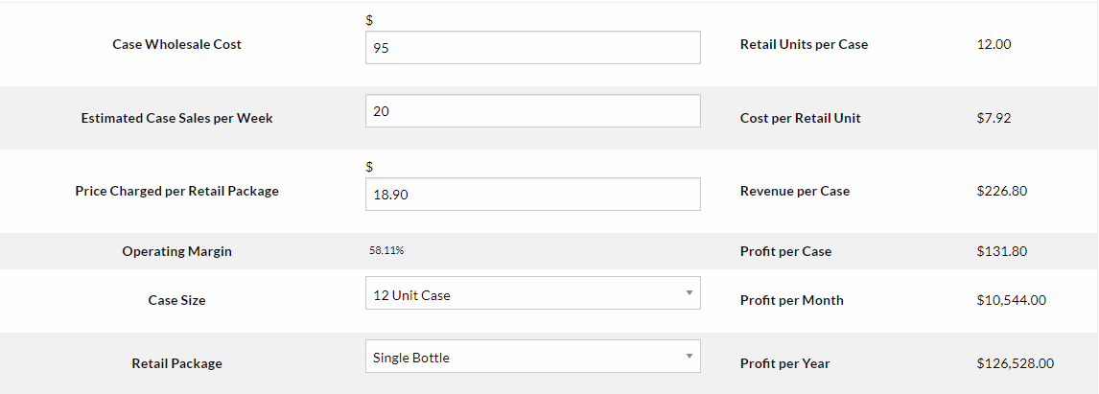

Beer
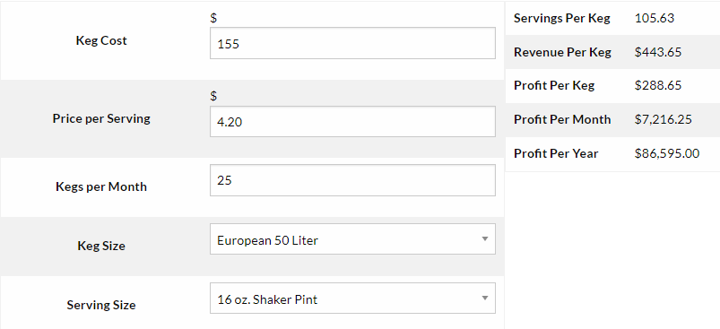
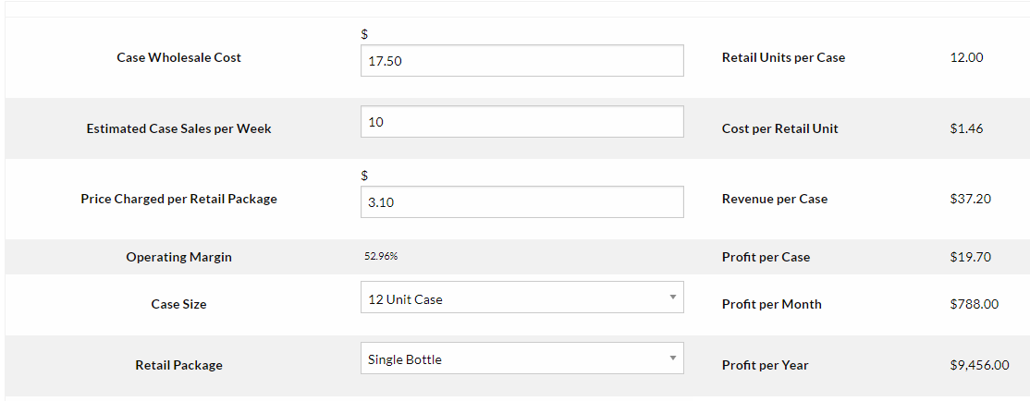
Non-alcoholic Beverages

2. Company Summary
Unibar is designed to bring together all people and create an environment that allows people to comfortably meet each other. This is done through the possibility to have a drink and share your favourite songs to everybody. This structure allows people to feel more comfortable in meeting new people at the bar because the uncertainty of how to act is eliminated. Singing is one of the easiest ways to get in a conversation with others. Therefore, we use the saying “music connects”.
Unibar will be set up in the University District in the inner city of Graz. This area is a rapidly emerging night stop for the targeted demographic. Because the rented space will be an old warehouse the lease costs are quite reasonable. The trade-off for the very reasonable lease is slightly higher tenant improvements required at start up.

2.1 Company Ownership
The ownership of Unibar is divided in three parts. Every owner (Sebastian, Philipp and Maximilian) owns the same percentage of this company.

2.2 Start-up Summary
Unibar will incur the following start-up costs:
Bar build-out and design – 140,000€
Bar supplies – 20,000€
Opening inventory – 15,000€
Working capital (to include 3 months of overhead expenses) – 15,000€
Marketing (advertising agency) – 5,000€
Accounting firm (3 months worth and establishment/permitting of business) – 10,000€ Please note that the following items which are considered assets to be used for more than a year will be labelled long-term assets and will be depreciated using G.A.A.P. approved straight-line depreciation method.

3. Products
Unibar sells the following:
- Eight microbrew beers on draft and in bottles: beer is served for two reasons. One, alcohol reduces inhibition, making it easier for people to meet and interact. Two, draft beer generates wonderful profits. Microbeers are chosen because they are of higher quality than large production beers and our target segment prefers them.
- Espresso, cappuccino, coffee, and other coffee/espresso drinks: coffee and coffee-related drinks are hugely popular, particularly in Austria. People here expect good coffee/espresso at most food/drink establishments, and it is often associated with polite conversation.
- An assortment of different cocktails and long drinks: Many women are attracted to good looking cocktails. We want to give our customers the feeling of vacation and relaxation to let their strict and exhausting life away. Furthermore, the average price of mixed drinks is higher than for beer, so it also affects the income.
- The Break-even: According to our knowledge and calculations, we need two weeks for preparation until we can open our bar. Afterwards, it takes two months to establish and get several fixed customers. Finally, we reach the point for return of investment after six months.

4. Market Analysis Summary
Unibar can be broken down into two diverse groups, students and adults. Both groups are well educated and are middle to upper-middle class.
Unibar competes within the bar/karaoke shop industry with a market niche focusing on student activities. By concentrating on these student activities, Unibar also faces competition from other pubs, bars and cafes.

4.1 Market Segmentation
Unibar’s customers can be divided into two groups: singles, and non-singles. The non-singles group is smaller by virtue of the fact that if you are meeting someone whom you already know, the two of you can come up with the topic of conversation yourself, therefore, Unibar offers this group less value. The demographic for the non-singles is similar to the singles, to be listed below. The demographics of the singles are:
- Single: self-evident.
- Professional: this characteristic is intuitive since the underlying element of Unibar is thoughtful conversation, and most, if not all professionals are intelligent and appreciate thought-provoking conversation.
- Income over €40,000: this to a large degree correlates to the fact that they are professional. The one exception are teachers who are underpaid relative to their contribution to society.
- Age 21-35: the largest group of singles looking for companions.

4.2 Target Market Segment Strategy
Unibar strategy will be based on communicating Unibar’s value to the targeted segments. This will be done through a variety of methods. The first method will be strategically placed advertisements. One place that will be used for advertisements is the Social Media account @unibar. We are posting on Instagram and Facebook on a weekly base. This will be the main source of advertisements because the demographics of their readership are fairly similar to Unibar’s demographics.
Another source of marketing will be done with companies that have similar customer demographics. One prime example is the bar Kottulinsky located in the university district 5 minutes away. This bar only opens at 2am and therefore does not overlap with our opening hours. Our partnership benefits from customers who go straight to Bar Kottulinsky after their visit to Unibar. We promote Kottulinsky as an after part and in return they promote us as a pre-party.
The other form of advertising will be using “UniCredits” methods where customers will be given coupons for their friends to try Unibar Shop for the first time. The coupon will be an economic incentive for the newcomer to try Unibar. The coupon also has the added force of a referral from a friend.

4.3 Industry Analysis
Unibar competes within the general bar/pub/cafe shop industry.
The bar industry is an overly broad industry. Participants in the industry do not seriously focus on specific niches. Sure there is a flavour to specific bars, but it is not an overwhelming trait. An example of this might be a sports bar that will typically have multiple TVs with sports on. Beyond this “decoration,” there is not a significantly prevailing theme other than the place that serves alcohol. The value that bars offer is a place where someone can go to get alcohol in a social setting. A secondary benefit is an opportunity to meet people. Please see the Product and Services section for commentary on the effectiveness of a bar’s ability for people to meet people. To conclude, most bars have some sort of theme, but overriding theme is a place to socially consume alcohol.
The coffee shop industry is made up of diverse coffee shops that typically serve coffee and assorted coffee drinks as well as various food offerings. Coffee shops are places where people will go to enjoy their favourite coffee beverage, to read a newspaper and relax, or to meet people and engage in conversation. This last purpose of a coffee shop is an unstructured, unstated purpose. It takes place at the hands of the patrons as opposed to a concerted effort by the establishment.

4.3.1 Competition and Buying Patterns
The competition comes from several dissimilar sources.
- Bars: there are many diverse types of bars or pubs. Some are better than others for meeting people, however, none have the business mission to bring together students.
- Coffee shops: coffee shops are typically an easy-going social setting that does lend itself for people to meet others. Conversations occur in part because of the historical underpinning of coffee houses, in part by virtue of the fact that the background music is not blaring. Coffees shops rarely have any type of organized activities to bring singles together.

5. Strategy and Implementation Summary
Unibar’s implementation strategy is based on a targeted advertising campaign as well as word-of-mouth referrals. Unibar is confident that the referrals will be an excellent source of business because of the uniqueness of karaoke as well as its sheer effectiveness. Unibar will steadily build a loyal customer base.

5.1 Competitive Edge
Unibar competitive edge is based on their unique approach to getting students together using the karaoke theme. This theme was detailed in the Product and Services section, please refer to that section for more information.
This system is a competitive edge because most bars/taverns to not have a niche that they are truly concentrating on. While every bar or coffee shop has a certain “flavour” and that is why someone will choose one bar or another, the flavour is only surface deep. The business model of the establishment is to sell alcohol and provide a social setting. Beyond these two values, there is little other genuine value that the establishments try to provide.
Unibar is distinguished by the fact that their business model concentrates on developing value for customers beyond serving drinks. Unibar an effective, albeit inherently structured or artificial, social setting that encourages meeting like-minded individuals for sing and drink. Providing the drinks is the source of income, an ancillary part of the business model. Generating value for the customers is the main focus, if the customers are happy then the revenue will follow (assuming of course that proper marketing and financial controls are employed). Concentrating on the client’s needs beyond serving alcohol is the distinguishing characteristic that will allow Unibar to rapidly gain market share.

5.2 Sales Strategy
Stated in an earlier section, the competitive advantage of the karaoke theme is what will drive people to Unibar and will develop long-lasting customer relationships. What will drive the bottom line beyond creating loyal customers, is revenue generated from sales of drinks and food.
Providing a rotating selection of premium micro beers will be one sales strategy. Micro beers, particularly on tap, have great profit margins. The servers will be well trained in the different beer offerings to provide the customers with in-depth information. Offering a rotating selection will encourage people to visit often and try new beers.

Sales Forecast
Sales
Drinks | €105,921 | €271,254 | €296,874
Direct Cost of Sales | Year 1 | Year 2 | Year 3
Drinks | €26,480 | €67,814 | €74,219

5.2.1 Sales Forecast
The first two months will be used to set up the physical location, hiring personnel, as well as establishing vendor relationships getting an alcohol license. The third month will be the grand opening. Business during the second month will be understandably slow as a steady customer base takes time to build. By month four it is forecasted that sales will steadily grow. Profitability will be reached by year two with sales exceeding €450K.

5.3 Milestones
Unibar will have several milestones early on:
- Business plan completion. This will be done as a road map for the organization. This will be an indispensable tool for the ongoing performance and improvement of the company.
- Set up the physical location and vendor relationships.
- Unibar’s first month of profitability.
Milestones
Milestone | Start Date | End Date
Business plan completion | 01/03/2022 | 06/05/2022
Set up the physical location and vendor relationships | 01/03/2022 | 06/07/2022
Unibar’s first month of profitability | 01/11/2022 | 01/12/2022

6. Management Summary
Sebastian, Maxi and Philipp are the owners of the bar and were former soldiers. They degreed on the military academy in military leadership. Sebastian worked in several part time jobs as a waiter, Philipp worked already as a barkeeper on birthday parties and Maxi attended a collage with focus on accounting.
After the graduation on military academy, the owners decide to continue their career at the Austrian Armed Forces. After about 2 years, they realised that this job is not suited for them anymore. Since Maxi and Sebastian both live in Graz, they already knew each other well. They have often discussed the fact that there is still no karaoke bar in Graz. Since they had unceremoniously quit their job in the military, they came up with the idea to open a bar. Philipp heard about this idea and wanted to join, because he was not satisfied with his job anymore.
Sebastian, Philipp and Maxi realized that the desire for a karaoke bar in Graz had been there for a long time. However, no one has yet followed up on this idea. This is the perfect chance to do the first step.
However, since the owners have little to no forethought of starting a business, the idea stalled at first because they did not know how to approach it.
They started talking to owners of other bars and getting ideas to create an innovative bar.
This led to the writing of the business plan for Unibar.

6.1 Personnel Plan
Management:
Sebastian fills the warehouse. He is responsible for the acquisition and purchase of products in long term. He is also responsible for accounting and legal matters.
Philipp empties the warehouse. He will be in charge of developing the drink menus, training of staff,
Philipp is also the personnel resources manager and leads the job interviews. Everybody who is interested to work for us, gets the possibility to write an email with job application. On our social media, people will see, that we are hiring employees.
Maxi fills the bar with customers. He will also work directly with social media companies and marketing companies to make sure his business is compliant and is frequently reaching a large audience and ensuring customer service. Max will hire a third-party marketing company to develop the website, social media accounts, photography, and maintain the online presence.
Work team:
3 part-time bartenders to serve drinks, help clean, and provide excellent customer service.
M/W 20-35
2 bar backs to assist the bartenders with cleaning and service.
M/W 20-35
1 liquor attorney to ensure all compliance regulations are being met. M/W 20-35
Owner | €36,000 | €2,571
Bartender | €14,400 | €1,028
Bar Back | €11,200 | €800
Dishwasher | €11,200 | €800
Total People | 4 | 4
Total Payroll | €144,900 per year | €5,200
Personnel Plan:

7. Important Assumptions
The following table details important financial assumptions.
General Assumptions
Plan Month | 1 | 2 | 3
Current Interest Rate | 10.00% | 10.00% | 10.00%
Long-term Interest Rate | 10.00% | 10.00% | 10.00%
Tax Rate | 30.00% | 30.00% | 30.00%

7.1 Break-even Analysis
The Break-even Analysis indicates that approximately €25,000 will be needed in monthly revenue to reach the break-even point.
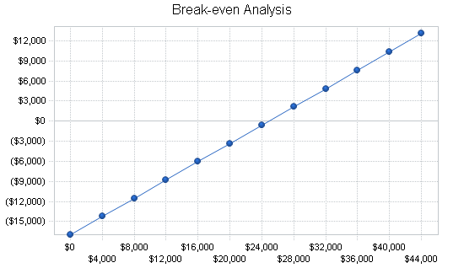

Break-even Analysis
Monthly Revenue Break-even | €24,867
Assumptions:
Average Percent Variable Cost | 32%
Estimated Monthly Fixed Cost | €16,969

