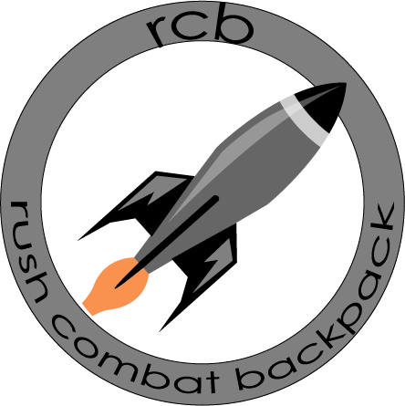
Inhalt
About Us 3
Project 6
Owners 6
Way to the Product 7
Protection of content 7
Company Characterization: 8
Our future customers 9
Product description: 9
Technology and Production Plan, Innovation, R&D 10
Human resources: 12
Project Area 12
Calculation of Prices 12
Marketing Mix 14
Break-Even Point 15
Cash Flow 16
Sewing Machine and Cutting Tools 17
Factory 20
Project Timeline 21
Projectplan 24
SWOT analysis 25
In the attachment 26

About Us
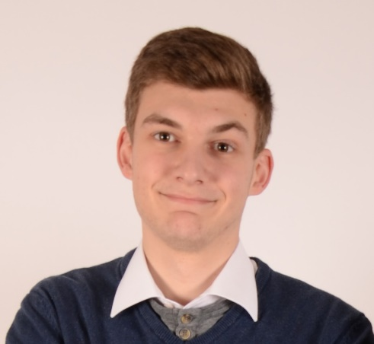
Hello my name is Stefan Jenschik and I´m 21 years old. Before I came to the army, I went to a business school. There I had a lot of subject which prepared me to work in a company. There I learned a lot of things such as business administration, business accountancy, marketing and web design. Because of my former skills I have a lot knowledge that helps us in our project. My goal is to make us one of the best backpack company in this branch. To achieve that, we have to make sure we approve our work constantly and look at our production optimization.
I will be in charge of our marketing department and make our website and booklets. It is necessary to make a website which gives as much information about our product, have good photos and tell there why our product is the best on the market and what is the special on it. But most of the time we have to go to the army direct to adverse our product and let them test it directly that they see if it fits to their needs.
With our project we won´t be able to gain instantly a lot of profit because we have to search some time to be efficient and make the process as easy as possible to save time. We have to start with only few products to find the optimal production process and which materials are the best to use. There we have to look for materials who are easy to work with but also withstand a lot and have rain protection. We have also to decide how many of the materials we are buying for our storage to have enough but not too much.

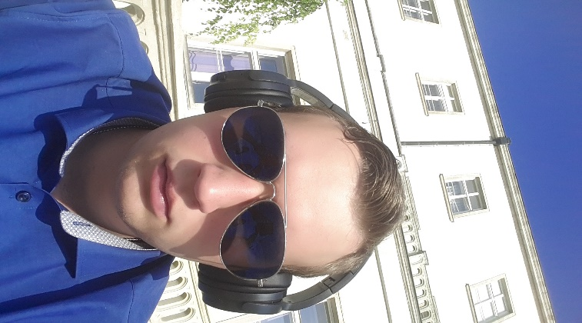
My name is Elias Türtscher and I am 21 years old. Before I came to the military, I went to a high school for textile work for 5 years. I learned there how to work with this material and how to use some of the machines necessary for our company. They also thought me how I can see if the materials we use are good ones or not so good. Because of the 5 years in this school I have now a great know-how which is important for our company. My goal in my sector of the company is to motivate the workers to work exactly and make the best backpack ever. To achieve that the backpack should not be damaged so easily, and the seam should be done well and the zippers should be sewn in the backpack well, too.
As mentioned, before I will be in charge of the production department of our company. It is necessary that in every department one of us is the leader because we manager costs so much more money and if we are the manager of the department it will be much cheaper for the company. And we are lucky that everyone of us is specialized in one part of the company.
We all know that we need 4 years till every depts are payed back. So, we will earn money after the 4 years and we have to sell around 800 to 1000 backpacks a year. To achieve that the workers we hired have to work constantly and focused on the product. Because we want to give our clients the best produced backpack which cannot be damaged. If we manage that they will be happy with our product and buy more of it or they will tell others how well the backpack is and we will get more clients and sell more backpacks.

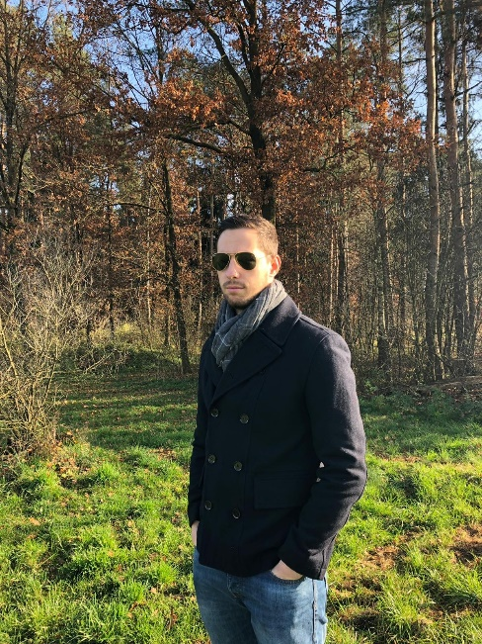
Hello, my name is Marcus Juch and I’m 23 years old. Before I joined the Austrian Armed Forces. I went to the Alpen-Adria Gynasium in Völkermarkt. There I had the focus on Informatics. Therefore, I know a lot about information system and how to work with them. My goal with this whole rucksack project is to make us a flourishing and wealthy company. The focus and foundation for that is hard work and high-quality standards.
In my time at the army I was an instructor for basic training for recruits. There I gathered a lot of experience on how to work with subordinates and people. Also, I had a deployment on the border for over one month and worked there with the police and controlled civilians. Therefore, I can say that I have a great experience with people, and I know how to manage task very efficient.
Because of that I will be the person on charge of personnel in our company. Starting from hiring, promotion and administration. The search for our employees will be focused around the flowing attributes: hardworking, intelligent, team player, politely and loyal.
Why hardworking? Because in the first phase the success of your company lies one the shoulders of all employees, regardless the place in the hierarchy of the company. Then we need intelligent people and team players. Intelligent is not meant in the way that we need geniuses but people who think about great overall picture instead of the small one. They need to understand how important ever so small action is for a company.

Connect that with a team player and our company has an even higher chance of success, because with only individuals as workers the working climate is not good, and it affect in the end the functionality of the whole company.
And in the end, we need loyal employees. Without loyalty the danger of espionage occurs, and we cannot afford our idea and system get stolen by a rival or bigger company.

Project
Our Project is a backpack system which consist of two backpacks. One Backpack is for the important things a soldier needs in combat situations like ammunition for heavy machineguns, food and clothes. The other backpack is for not so important things like sleeping back, isolation mate and other equipment. If necessary, the second backpack can be dropped easily with one move so that the soldiers can withdraw faster.
It is called the Rush Combat Back (RCB)

Owners
My name is Elias Türtscher. I am in the Austrian Armed Forces (AAF) since 2016 and I have experienced that the equipment in the AAF is not that good for fast movements and therefore my comrades and I have invented this new backpack which allows faster and better movements. Before the military I have studied for 8 years in a high school which taught us a lot how to use stuff and how to work with it. Therefore, I am the expert for processing of this backpack.
I am Stefan Jenschik and I work since 2016 at the Austrian Armed Forces. Since my first field experience I noticed that the Austrian equipment isn’t good and not useable. My experience of web design before the military I am the person who have the part of the best advertisement in the web. Therefore it’ s my job to make the best content on the site.
At last my name is Marcus Juch and I am since 2015 in the AAF. After doing the normal military service, I stayed at the military training privates and I was deployed at the border for 1 and a half months. Therefore, I know how to work with different kind of people and how to use their own individual skills in the most efficient way. So I am in charge of all the personal matters of our company.

Way to the Product
The product will cost something between 250 to 350€. It is invented for Army’s and special forces who need to move fast and quiet with heavy backpacks. The marked is new we only have one competitor because the Austrian Armed Forces has invented a system which is quite similar but is not that good.
Financial: We will produce our product in Hungary to save some money for the factory and the workers. But it will still cost us about 400.000€. Therefore, we have to sell at least 1200 backpacks so that we do not have lost money. We expect that our first contract will be at least 300 backpacks so that the Army has some of them in reserve.
We will invest about 100.000€ by ourselves and our whole time as well as our knowledge of our web design, material know-how and personal management.
To begin with the production, we need a t least 9 months to find some good supplier and to produce the first typ of the backpacks. Of course, we will optimise the product regularly and ask our clients to give us feedback how the backpack behaves in combat situation and how to improve it.

Protection of content
The content of our website has been compiled with meticulous care and to the best of our knowledge. However, we cannot assume any liability for the up-to-dateness, completeness or accuracy of any of the pages. Pursuant to section 7, para. 1 of the TMG (Telemediengesetz – Tele Media Act by German law), we as service providers are liable for our own content on these pages in accordance with general laws. However, pursuant to sections 8 to 10 of the TMG, we as service providers are not under obligation to monitor external information provided or stored on our website. Once we have become aware of a specific infringement of the law, we will immediately remove the content in question. Any liability concerning this matter can only be assumed from the point in time at which the infringement becomes known to us.
Copyright The content and works published on this website are governed by the copyright laws of Austria. Any duplication, processing, distribution or any form of utilisation beyond the scope of copyright law shall require the prior written consent of the author or authors in question.
Data protection A visit to our website can result in the storage on our server of information about the access (date, time, page accessed). This does not represent any analysis of personal data (e.g., name, address or e-mail address). If personal data are collected, this only occurs – to the extent possible – with the prior consent of the user of the website. Any forwarding of the data to third parties without the express consent of the user shall not take place. We would like to expressly point out that the transmission of data via the Internet (e.g., by e-mail) can offer security vulnerabilities. It is therefore impossible to safeguard the data completely against access by third parties. We cannot assume any liability for damages arising as a result of such security vulnerabilities. The use by third parties of all published contact details for the purpose of advertising is expressly excluded. We reserve the right to take legal steps in the case of the unsolicited sending of advertising information; e.g., by means of spam mail.
Proposal: If you invent in our product, we will give you 3% of our turnover.

Company Characterization:
Name: RCB
Tel. +4368181609877
E-Mail: elias.tuertscher@gmail.com
Website: www. rcb.at
Address: Vienna Hütteldorferstraße 30
Legal Form: GmbH:
Start-up company
No certificates yet but we are looking forward to be the most employees friendly company in Austria
Company structure: We 3 are the head of this company but everyone has his own specializations. As mentioned before Stefan Jenschik will be in the IT part of the company, Elias Türtrscher will be in the production sector and development and Markus Juch will be in the personal management part of the company.
Vision: RCB: A better item for Austrian Soldiers in combat situations.
Mission: RCB: A better life for every soldier
We will set our prime activities on advertisement and production

Our future customers
Only for Soldiers and militaries, therefore we only have one specific costumer, Measurable selling numbers is about 200 Backpack/year which is possible to achievable because most Armies buy Backpacks in big numbers so we calculate with at least 300 Backpacks per order. We will make advertisement on our web site and sell these backpacks to special forces so that they will recommend the product to other soldiers. Evaluation is the feedback of the soldiers who were in combat situations. We will improve the backpack on the results of the feedback and ask the soldiers to reevaluate the new and improved backpack.
We will set our prime activities on advertisement and production
Product description: 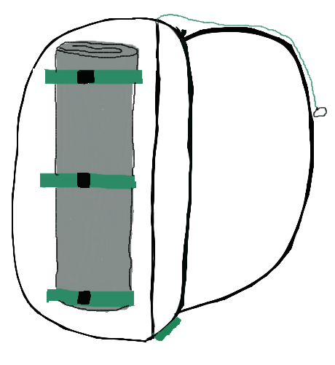

The product is in the development phase now. After this we will produce 10 backpacks and test them on the normal field situations like rain, stability and resilience. The backpack consists of waterproofed material. Therefore, the soldiers do not need any rain shelter for the backpack. The two bags can be opened and closed with a zipper and there are two extra zippers at each side of the backpack so that the second backpack can be dropped in combat situation. It also has fishplates at each side of the big backpack to attach something like an isolation mate or a sleeping back. In the smaller backpack there is a skeleton of aluminum metal to give the backpack its size and stability. The shoulder straps can be easily modified for each soldier. Therefore, it will fit for every soldier perfectly. We also foam to improve the comfort of the backpack. In total the backpack can hold about 120 liter.

Technology and Production Plan, Innovation, R&D
Production: We will hire employees who will produce the backpack by hand but every worker will only do one thing and they will work in a line and in the end the backpack will be ready.
Production Demand: To build our backpack we need a fabric which is about 200 m2
We will use sewing machines and cutting machines to cut the stuff and get the pieces together.
Material: waterproof stuff (cordura) and foam
Energy: electric energy to use the machines
work: use of handwork
Time calculation:
 | Persons
Hours | 5 | 10 | 15
1 | 2 | 4 | 6
2 | 4 | 8 | 12
4 | 8 | 16 | 24
6 | 12 | 24 | 36
8 | 16 | 32 | 48
12 | 24 | 48 | 72

 | Production output per week with 8 hours of work
workers | first week | second week | third week | Fourth week
5 | 80 | 160 | 240 | 320
10 | 160 | 320 | 480 | 640
15 | 240 | 480 | 720 | 960

The calculation of the monthly production is based on a 5-day week with optimal work process. To be realistic we can say we do not rush to fast in the production because we have to optimize and correct mistakes of the design if it can´t be product that way we thought.

Logistic: The stuff will be sent by our subcontractor and we use the public transport system and not one special but the one who is cheapest to transport the backpacks to the stores in Austria
Fix Costs: payment of the workers, rent of the building, assurances, cleaning company for the building, Electricity
Variable costs: transport costs, production cost, development,
Work Safety: every year the regular checks (use of machines, fire escape plan, accidents, …)
Political stability is given because we produce in the EU/Hungary. Also, we do not have to follow EU standards for the rucksack, but for the safety and health measures in production.
Production in Hungary would be the best option because its close to Austria and the average wage there for specialized workers is around 949€. (60% less than in rest of EU)
The level of education is acceptable for our company in Hungary.
We don’t need to transfer technology because we just need a normal factory building and get the machines for automatization on our own.

Human resources:
At the beginning we will have about 10 employees for using the cutting machines and the sewing machines. We will outsource the cleaning for the factory and the office. These employees will work in 1 shift but not all at a time because this way we can save money for the machines and have some machines for reserve if one is broken. We also hire one employee who will look after the machines. This employee does not need any qualification although we will prefer employees who had already worked at the sewing machine or the cutting machine because this way, we do not need to train them on it. We think a good way to Motivate them is that at the end of a month or year there will be a vote who is the best employee (Works hard, helpful, makes the most backpacks,) This employee will get a bonus about 20€/month and 50€/year. They will get about 800€/month because they do not have any responsibilities and do not have any competences.

Project Area
- factory hall ~200m² in Pécs (industrial city)
- in industrial zone, close to other companies
- Close to bus network or other public traffic systems
- parking places for around 20 people
- Networks: Internet, electricity, water and waste
- Sales and Marketing

Calculation of Prices
Backpack Costs
- Material Costs 25€
- Production 25€
- Marketing/Promotion 25€
- Costs of Distribution 25€
Total Fix Costs 100€
Selling Prices 300€

Make better conditions for buyers
Frequency discount at 100 pieces of 25€ per unit so it costs 275€
Frequency discount at 200 pieces of 50€ per unit so it costs 250€
Pieces | Profit
 | 200€ | 175€ | 150€
10 | 2.000€ | -
50 | 10.000€ | -
100 | 20.000€ | 17.500€
150 | 30.000€ | 26.250€
200 | 40.000€ | 35.000€ | 30.000€
250 | 50.000€ | 43.750€ | 37.500€
500 | 100.000€ | 87.500€ | 75.000€
1000 | 200.000€ | 175.000€ | 150.000€

Because of the investment of 400.000€ to start the business we have to sell a lot of our backpacks to get profit from our idea. The best for us would be if we sell around 1000 pieces a year. The optimal way to sell our product would be if we sell 1000 pieces with a profit of 200€ each. If we combine all three different profits it would be like 200*200€, 300*175€ and 500*150€ so we will earn 167.500€.
Are we calculating to earn around 100.000€ a year to pay back our credit we need around 4 years that it is profit for the company. We just must sell around 820 backpacks if we sell them like 120*200€, 200*175€ and 500* 150€ so we earn around 134.000€ but the fix of 20.000€ are not calculated into the calculation. We have to pay that too therefore we have to sell 680 to 800 more backpacks per year.

Marketing Mix
Our company will only produce this product for the militäry at the beginning. Therfore we do not need much advertisment because the militäry is not interrested in good edvertisment. We need sellmen who go to the militäry and show them the backpack. After some months when a lot of people have tried the backpack during their working hours and want to buy the backpack for themselves we infent an online shop so they can buy it there. Hopfully some shops like steinadler or blackshadow will be interrested in this product to and will sell it in their shops. After that we will make some advertisement on our Facebook page to increase our costumers to the civil population.
As mentioned before we will use the cheapest transportation company to get our products to every country in Europe and sell it to each army or shop.
We are the only company which produce such a backpack and we have the patent on such a system therefore there is not a real competitor who can produce cheaper. Furthermore we will start with 300€ per backpack and if the market do accept our product well we can sell it for less.

Break-Even Point

The break-even point is 100 backpacks.

Cash Flow
As we can see in this diagram, we need between 4 and 5 years to pay back everything. If we sell 140 – 150 backpacks per month.

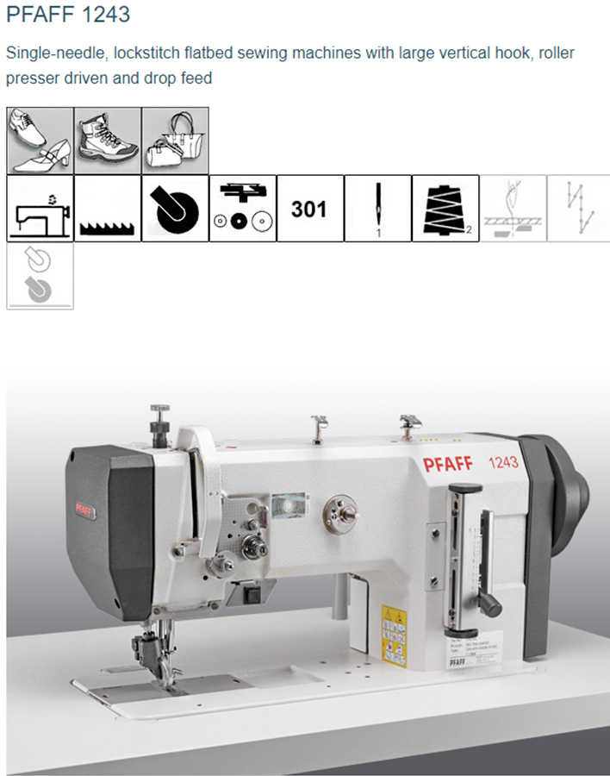
Sewing Machine and Cutting Tools
To choose the correct sewing machine you have to look closely on the purpose you have. These three machines are all made to sew many materials and are made for the industrial use. They are all costing between 2.000€ and 3.000€ but you can´t take them by the price. So, make some test runs to find out which one fits the best for the company:
Also, for the cutters, it is necessary to test them and decide later which one is fitting the best to be most efficient. They are costing around 500€ to 1.000€.
At the beginning our company we are going to rent 3-4 pieces each and decide after some month which machine fits best and after that we buy 10 pieces of this machine.

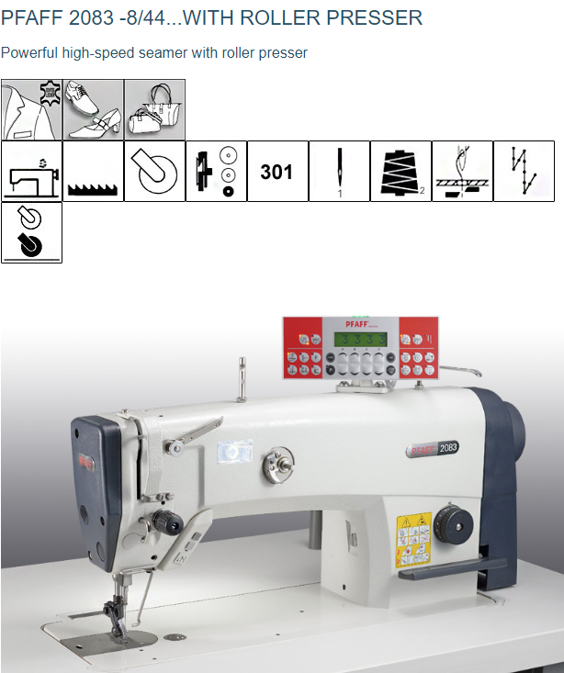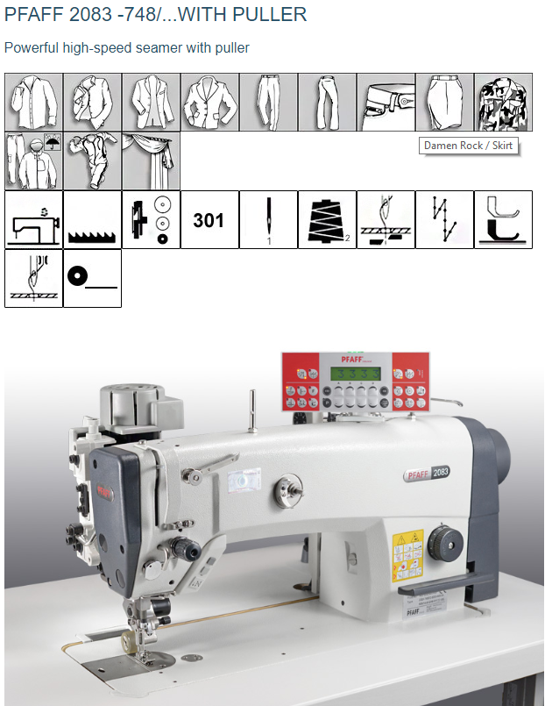

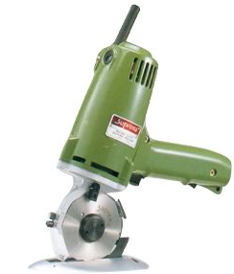
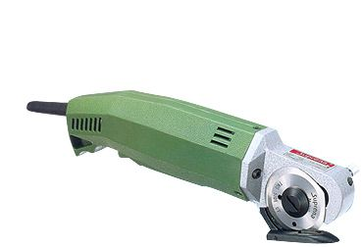
Mini knife cutters - HC 1007 AL, PC 1062 L
Electric cloth cutter - KS EU

Round knife cutters - CR 8 B, CR 1026 FRB & CR 1031
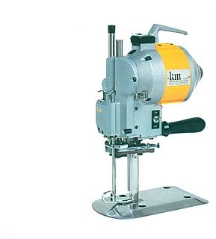

Factory
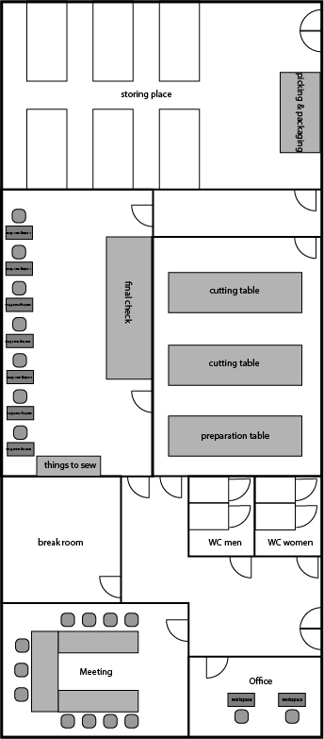

The Steps for the product
We begin with the ordering of the materials, like zippers, cloth and twine. After that it will be put into the storage. Then we take it from the storage to the cutting room. There we start with cutting of the material into the planned patterns. Afterwards it will be brought to the sewing room and there the different parts will be sewed together in different steps.
After the backpack is finished it goes under quality control. The focus for the control is the workmanship, the functionality of the zippers and the drop system. If the rucksack passes the check it will be brought back to the storage. Afterwards it is ready for distribution to the customer.

Project Timeline
First, we started with the development of the main idea. In our case it is the layout and system of the rucksack. As planned, it took us two weeks to accomplish that, because we wanted to take our time and make a real solid and dependable system. Without it we put the whole project in danger, especially the stage of testing, production and finding buyers. This is especially critical at the prototype stage. Because if we do not plan the layout of the rucksack carefully, for example if the separation system does not work, our whole idea becomes obsolete and we get a major drawback on the time table solving the issue.
Then we came up with a finance plan for the time from finishing the idea till the production of the rucksack. We included also one week in the later stages to revise the finance plan if problems occur or we miscalculated.
While developing the idea and doing the finance plan we checked the market for a similar rucksack, but we found no one. So, the conclusion of the step was that there is in fact a possibility for our rucksack to be sold and making thus profit. This whole step took us four weeks because we wanted to be absolutely sure and also, we could not work 24/7 for our idea at that moment. Mainly because we worked at our normal jobs at that time to earn money, because while planning we do not earn something with our idea.
Next came the infrastructure plan. Including the country where we want to produce and the exact city. This also included the needed machines, an office, number of workers and safety measures for work.
For the prototype 1 phase we planned three whole weeks, so that we will still be able to do some adaptation regarding the productions steps, layout of the rucksack and if there occur any problems (mainly because of things we forgot or did not put much attention on it).
Together with the first prototype, we want to find the right materials for the rucksack. But why do we split the prototype and the material into two steps? Simply because it it’s the first realization of the idea in real and when we do something wrong, we do not waste expensive material. Furthermore, we can in theory adapt the production process before we start producing and that way, we save production material again.

The planned material for the rucksack is Cordura. It is quite expensive but a high-quality fabric which has exceptional durability and tear strength. The following picture show Cordura up close.
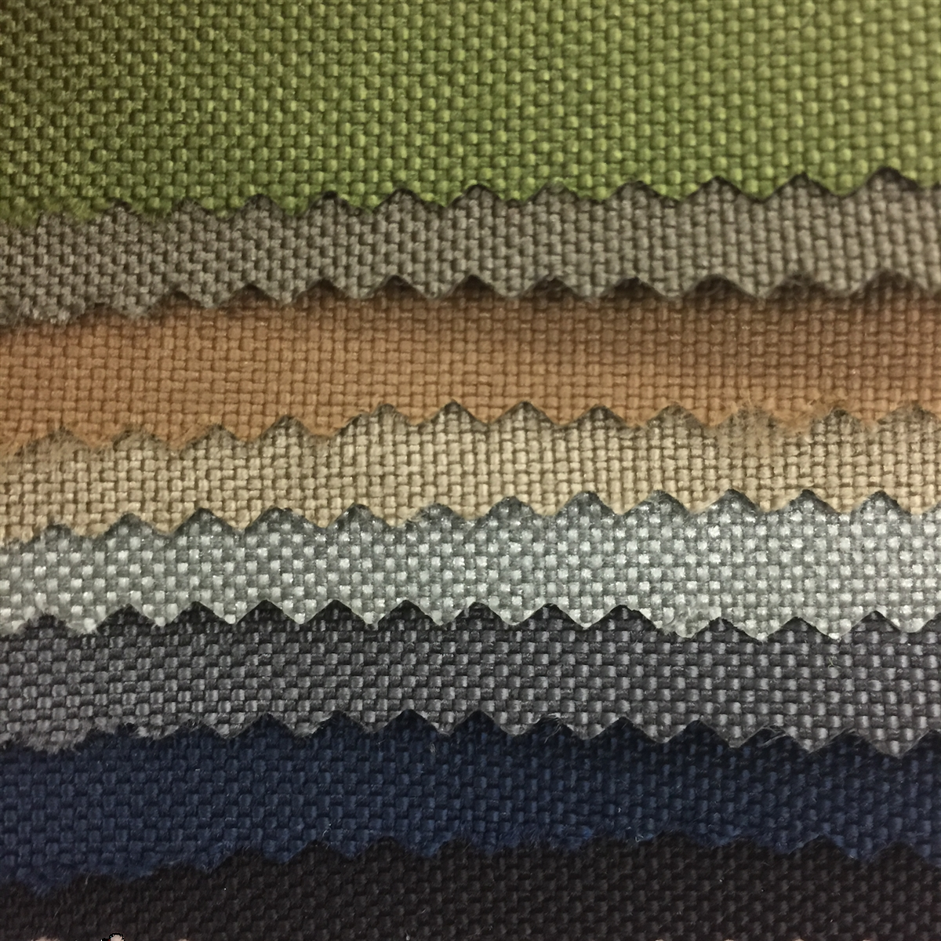
Following those two steps we start with prototype 2. The difference to prototype 1 is that it is produced with the original material we want to use for our final product. There will be 3 prototype 2. Two of them for test purposes and one for marketing.
For the testing phase we take our time to see how our product behaves in combat and stress situations. The main points here are longevity and durability. This includes situations like marching, climbing, swimming, dropping from great heights or being completely overloaded and full.
The main purpose for that procedures is that we to make a product with high quality standards because with that we earn a good reputation and its more likely that armies will buy the rucksacks. Also, for the long run we need to come up with new products and we have a good reputation it easier to introduce them to the market.
We will need now a facility to produce our rucksack. It takes us probably four weeks to get ready for production. Mostly to get the machines, infrastructure, workers and enough materials. At the beginning we will not produce fully automated, because it is cheaper for us.
For the beginning we plan to produce 200 rucksacks to have a reserve if we get a bigger assignment. Then we try to find a buyer and promote our rucksack. Why guarantee the production first? Because when we find a buyer, we can tell him that we are ready to go and have already small stock ready for delivery, so he can test it.
The next phase are changes. So, in case we face a problem in mass production, the facility or changes in the financial plan we have an extra week reserved. If having success this would also include expanding the facility, maybe automatization or hiring more workers.
And at the end we need to make financial calculation again, mainly because we will need to fix the budget for the next year. Especially if we have success and get many assignments with high production numbers. Then the problem will be how to spend the earned money carefully, like investing in new machines, expanding the facility, hiring more workers and how fast we pay the credit of the bank back.
At the end of this last step we have to make a new time table for the following year with a new goal, like increasing productions numbers or maybe start to develop a new idea. But for now, it is only speculation, because only time will show how successful our company and idea are and this plan is only an indication. Things may play out differently or in the worst case completely overthrow our plan.

Projectplan

SWOT analysis
 | Opportunities | Threats
Strength | Our main strength is that we have a new product optimized for the military market.  By using that new product, we can take the opportunity to find buyers and promote our product better. Also, if we plan carefully and get good chances, we can make good profit and expand our company easily. | Our strength combines with the threats show that we must plan all our steps carefully. Otherwise we can go bankrupt and loose our company. Or if we have success, a bigger company could try to buy ours and/or try to copy our product be a competitor.
Weaknesses | To secure our product we need to certificate our product. Furthermore, it is important that we get a patent on it, so that no other company can copy our idea easy and thus be a competitor for us. | First, as already said we need to get a patent on our product to save it against copying. Secondly, plan everything we do in longer term so that we avoid doing strategic mistakes. (e.g. loose to much money or avoid getting overtaken by a bigger company)

In the attachment
There we would list our CVs, Personal certificates, Patents and Contracts as well as the Market search.

