Inhalt
About Us 3
Project 6
Project Timeline 6
Owners 7
Way to the Product 7
Protection of content 8
Company Characterization: 9
Our future customers 9
Product description 10
Technology and Production Plan, Innovation, R&D 10
Human Ressource: 11
Project Area 12
Calculation of Prices 12
Marketing Mix 13
Product 13
Place 13
Price 14
Promotion 15
Break-Even Point 15
Estimated Costs and Cash Flow 16
Production Process and Machinery 18
The Flameless Ration Heater 18
Machines 19
Factory 21
SWOT analysis 21
In the attachment 22

About Us

Benedict Caminades, CEO
Hello my name is Benedict Caminades I am 22 years old. Actually I am officer cadet at the Theresian Military Academy. There I learnt a lot of things about leadership, management and strategic decision making. According to my military training I experienced the needs of a soldier without supply routes. My goal is to establish a company that serves mankind. People in hostile surroundings should have everything to make their live as less suffering as possible and maybe – if possible – enjoyable.
I am the head of our company. I am hard working and grateful. This main characteristics in combination result in a high demanding and reliable personality. I will expect much from my companions but in view of our goal to establish a well working business and support all soldiers in field or sportsmen that all try to reach remarkable will justify those expectations. I will stick to my ideals and my demands without being ignorant until we as a company can reach remarkable like our customers will surely. This dream, make remarkable and support remarkable, is my engine that lets me run unstoppable.
I am aware of the risks I and my two friends take on us. We will have immense loans and high sums of debts will come from investors that will expect fast results. I know our concept and product are and will be supreme that of our competitors. As long as we work together toward our goal, we will be successful. I am also aware of the fact that in the first years we will put all into this project without gaining anything. Nevertheless, our goal is to cover our expenditures until 2023 and this goal is very reachable.

Sebastian Speckner, Vice President
My name is Sebastian Speckner and I was born in Carcassonne in southern France. My family used to live on a houseboat and travelled relentlessly all through the Canal du Midi. I started my military carrier at the age of 15 and decided to become captain of a nuclear submarine in de Marine Nationale in France.I know exactly what the needs of hard-working people without any supply are.
I will be the 2nd in command of our company. I understand my role as a puffer zone between our beloved CEO and or hard-working employees. Because sometimes our CEO as a never-ending Storm wants to proceed too fast and wants too much. This is the moment where I have to say that if crops want to grow there has also to be some sun instead of storms all year long. Nevertheless, I am the supervisor of the technical service and the human resources management. Luckily, I was commander of a nuclear submarine with a crew of 70 men, so this will not be a big challenge for me.
This team of friends will succeed. I trust in our CEO as well as in the rest of our crew. I am convinced that our product will fit exactly to the needs of the market. Furthermore, I am confident that the sea will be on our side, wind will blow in our back and our anchor will be settled forever in the ranks of military suppliers.

Kevin Kranawetter, Nutrition Specialist
Kevin Kranawetter was born in Moin in upper Austria. My father was a local hunter and taught me everything about it from childhood on. My mother was dedicated to gather healing herbs and mushrooms to prepare food and any kind of tinctures. As I learnt to live nearly self-sustainable in my childhood, I got interested in every nutrition aspect. Till now I stick to this dedication. I graduated at the university of Xin-Ping because Chinese medicine relies heavily on nutrition solutions and made my PhD 2015 in Vienna where I finished my research on the influence nutrition has on performance of soldiers.
My honoured grandfather who died in 2016 had an old company that produced canned goods. The last decade the profit of the company stagnated and was lastly just run by his obsession of working. I gained this production side as a heritage and decided to renew the building and start the new company.
Even though, my family has been the owner of this property I am aware of the fact that I am far not that qualified for being the CEO of this old/new company. But I am qualified to be a consultant in nutrition aspects of our product. We want to help men that want to reach things no one before has reached. Our task is hard and far not easy but we three in our leading position are the right ones. No other company can compete with us in our specializations and experiences we made all over the world. Nevertheless I want to make this business I got from my grandfather who was a great businessman at his time proud even though he can not be a witness by himself.

Project
Our Project is a nutrition package that includes food for 24 hours for people that are under hard circumstances without any supply like soldiers on missions or extreme climbers. Our product is especially remarkable by its heating process that is caused by an chemical reaction. That means that you do not have to carry some kind of boiling system with you what safes weight and makes you faster. At the fabrication we focus on nutrients human body needs under hard circumstances.
The Product is called Survival Nutrition Package (SNP)

Project Timeline
Our production will start in December 2019. Until then things like the financial plan, the production of prototypes and the right choice of suppliers will be of concern to us.
From 20th October our prototype will be ready and we and our customers will be able to test it so we can adapt and improve the food rations. Finally the production should start at least on 1st December so that we can enter the market at the beginning of 2020 so that it is available to customers.
Further steps will be to test the quality of our product and to focus on the marketing of our survival nutrition packages.
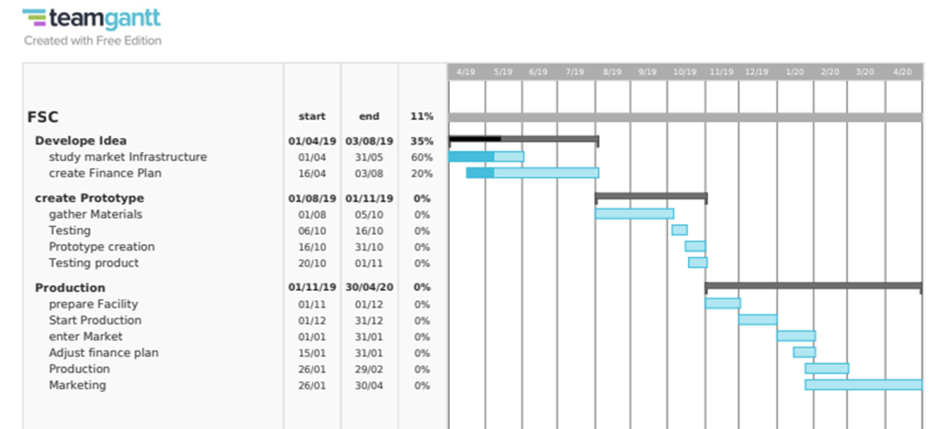

Owners
My name is Benedict Caminades. I am in the Austrian Armed Forces (AAF) since 2016 and I have experienced that the field nutrition is not that good for fast extreme situations and long ongoing missions. Because of my training as an Officer I am the ideal person to be the leader of this company. I experienced hard times in my live and I am not scared to go through hard times again.
I am Sebastian Speckner. I spend many years on sea and I decided to change my life. Even though you start something else you never can let the sea completely behind. I will use my technical experience and human resources management skills to bring our efficiency and productivity to the next level. As I was to used to a position with high responsibility, I do not run away from any appearing conflict that might be dealt with.
Last but not least my name is Kevin Kranawetter. I have studied everything I could have studied in the ambient of nutriments all over the world. One of the key wisdoms I revealed for myself is that everyone needs to make his role as he is shaped to. And I will do everything I am capable of, to offer the best possible product for men and women in dangerous situations to make their lives better.

Way to the Product
The product will cost 20€ per package. It is invented for Armyies and special forces who need to move fast and quiet with heavy backpacks. Also, extreme sportsmen and women are possible costumers because in their métier low weight is a key element to break any records. The marked is not new but not fed up with suppliers. In Austria we have one competitor that we will have to replace at the Austrian armed forces. Every responsible commander will bring the best product to his soldiers, even more if it is cheaper than from the competitors.
Financial: We will produce in the production side of Mr. Kranawetter. The yearly costs will be about 734 000 €. Therefore, we have to sell 40 000 Packages per year to cover these costs. We will be capable to feed the complete need of the Austrian Armed Forces.
We will invest about 750 000€ by ourselves and our whole time as well as our knowledge of, material know-how and personal management nutrition and technological processes.
We will stay in thick contact with our main costumers to improve or product at any time.

Protection of content
We will establish our website by ourselves. We will use open source programs that make it possible to design a professional homepage at low costs.
The content of our website has been compiled with meticulous care and to the best of our knowledge. However, we cannot assume any liability for the up-to-dateness, completeness or accuracy of any of the pages. Pursuant to section 7, para. 1 of the TMG (Telemediengesetz – Tele Media Act by German law), we as service providers are liable for our own content on these pages in accordance with general laws. However, pursuant to sections 8 to 10 of the TMG, we as service providers are not under obligation to monitor external information provided or stored on our website. Once we have become aware of a specific infringement of the law, we will immediately remove the content in question. Any liability concerning this matter can only be assumed from the point in time at which the infringement becomes known to us.
Copyright The content and works published on this website are governed by the copyright laws of Austria. Any duplication, processing, distribution or any form of utilisation beyond the scope of copyright law shall require the prior written consent of the author or authors in question.
Data protection A visit to our website can result in the storage on our server of information about the access (date, time, page accessed). This does not represent any analysis of personal data (e.g., name, address or e-mail address). If personal data are collected, this only occurs – to the extent possible – with the prior consent of the user of the website. Any forwarding of the data to third parties without the express consent of the user shall not take place. We would like to expressly point out that the transmission of data via the Internet (e.g., by e-mail) can offer security vulnerabilities. It is therefore impossible to safeguard the data completely against access by third parties. We cannot assume any liability for damages arising as a result of such security vulnerabilities. The use by third parties of all published contact details for the purpose of advertising is expressly excluded. We reserve the right to take legal steps in the case of the unsolicited sending of advertising information; e.g., by means of spam mail.
Proposal: We offer Investments in total up to 500 000 €. This amount will result in 33% of our company.

Company Characterization:
Name: FSC (Field Supply Corporation)
Tel. +436644365971
E-Mail: fsc.contact@gmail.com
Website: www. fsc.at
Address: Bahnhofstraße 17
4020 Linz
Legal Form: GmbH:
Start-up company
No certificates
Company structure:
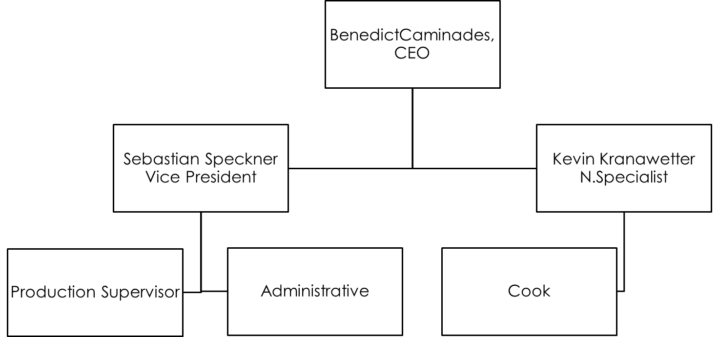
Vision and Mission:
Stop suffering start living. This survival food can be taken with you through their small and lightweight waterproof packs on every mission and every trip. Simply and quickly prepared, our product provides the necessary energy and tastes like a menu in the restaurant. The goal of our novel product is to help many people and especially the soldiers to survive in the wild and in extreme situations.

Our future customers
Our main customers will be European Armed Forces at first we want to gain the Austrian armed Forces as our main Costumer, our production is aimed to fulfill the complete needs of that army. This will be expected to be about 30000 packages per year. Most probably this contract will last for many years. We will collaborate with those main customers to generate evaluations to improve our services.
Other customers will be extreme sportsmen and women, camper and survivalists. We will offer to sports shops and adventure shops.

Product description

Currently our product is in the development phase. The finished concept already exists.
The survival nutrition package is designed to sustain an individual engaged in heavy activity such as military training or during actual military operations when normal food service facilities are not available. The Product is a totally self-contained operational ration consisting of a full meal packed in a flexible meal bag. The full bag is lightweight and fits easily into military field clothing pockets. Each meal bag contains an entrée and a variety of other components as may be seen in the table of Menus.
The entire meal is ready to eat which can be very important especially for soldiers. While the entree may be eaten cold when operationally necessary, it can also be heated in a variety of ways, including submersion in hot water while still sealed in its individual entree package. Also flameless ration heating device is also packed into each meal bag to heat the entree.
We also attach great importance to the sustainability of our product and try to avoid plastic and unnecessary garbage.

Technology and Production Plan, Innovation, R&D
Production: FSC will hire 10 qualified workers (2 cooks and 8 assistants). The whole production should run in a row until the finished product is packaged and ready for sale
Production Demand: For our production we need a small factory building with corresponding kitchen (hygiene standards). The kitchen also has special dryers / dehydrators to preserve the food.
Producs: Food and packaging are purchased from regional suppliers
Energy: electric energy to use the machines
Work: Nearly all will be done by hand.
Time calculation:
The staff will work 8 hours a day from 5 am to 4 pm, 5 days a week (Monday to Friday). They will have 5 weeks of holiday. To be realistic we can say we do not rush to fast in the production because we have to optimize and correct mistakes of the design if it can´t be product that way we thought.
The aim ist o produce 40 000 packages a year so we have to produce about 820 packages per week.
Production overview
Week | 820 Packages
Month | 3280 Packages
Year | 40000 Packages

Fix Costs are the payment of the workers, assurances,Electricity
Variable costs: transport costs, production cost, development, costs of the foods
Work Safety: every year the regular checks (use of machines, fire escape plan, accidents, …) A hygiene check is also carried out every month. In addition, continuous quality assurance is carried out.

Estimated Costs
Personal | 53 200€
Energy | 150€
Rent | 1350€
Resources | 6500€
Total | 61200€

Human Ressource:

Counts of employees.
Production Side Administrative Side
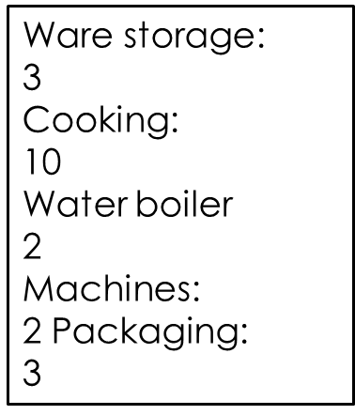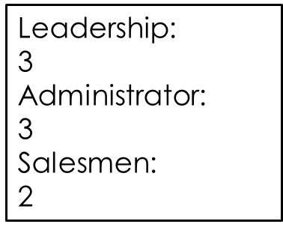

Project Area
- factory hall ~200m² in Linz (industrial city)
- in industrial zone, close to other companies
- Close to bus network or other public traffic systems
- parking places for around 40 people
- Networks: Internet, electricity, water and waste
- Sales and Marketing

Calculation of Prices
Package Costs
- Material Costs per package 6500€
- Personal Costs: 53 200€
- Energy: 150€
- Building Upkeep: 1350€
Total Fix Costs 61 200€
Selling Prices 20€

Pieces | Profit
 | 17,50€ | 20€ | 25€
1500 | 26 250€ | 30 000€ | 37 500 €
2000 | 35 000€ | 40 000€ | 50 000€
2500 | 43 750€ | 50 000€ | 62 500€
3000 | 52 500€ | 60 000€ | 75 000€
3500 | 61 250€ | 70 000€ | 87 500€

Marketing Mix

Product
Our Product is the Survival Nutrition Package which provides you with food, minerals and energy for up to 24 hours. It is specially designed for people working in harsh conditions, mainly for soldiers and extreme sportsman- and women. The special feature of our product is the self-heating process which allows the user to cut any additional weight like water, gas-cooker and gas-cartridges. The food itself is enriched with minerals, electrolytes and vitamins which provide the optimum nutrition for keeping the user in form for long periods of time. Our self-heating process is caused by a chemical reaction, you just have to pour a small amount of water in one of the bags. This means you don need any additional boiling device. This safes weight and makes you faster and more mobile.
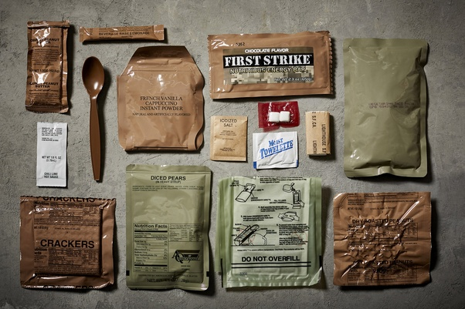

Place
The factory of our Product is located in Bahnhofstraße 17, 4020 Linz in upper Austria. Originally our company was founded in 1977 by Kevins grandfather Georg van Kraningen and established the ready to eat meals in the form of metal conserve cans in eastern Austria. Because of the global economic crisis and his lack of power to fight the company back to business he decided to hand the company to the next generation. Since 2016 with the new leadership the company has adopted its set to the new global setting. The factory provides all the sufficient room and safety standards you need in Austria to produce food. The main advantage of the factory´s location is the direct access to the A1 highway as well as near located train station and the access to the Danube river which allows efficient logistics.
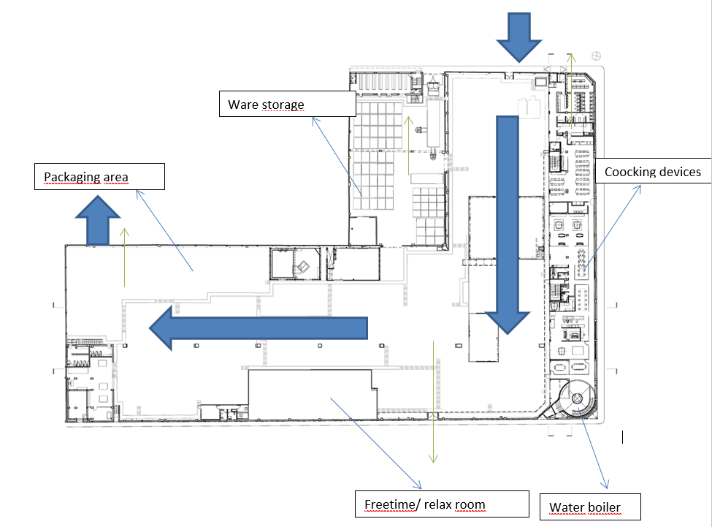

Price
The product will 20€ per package, which is about 3€ cheaper than the competitive product. This makes it more attractive for the Armed forces to buy because the main factor for military tranche buying is the lower price.

Promotion
Our main promoting campaign will be the initial contact and promotion of our novel product trough our salesmen directly with the military procurement. Our next step will be the distribution of promoting videos to announce our online shop and to increase the awareness of the civilian sportspeople. These videos will be mainly distributed on internet platforms like YouTube because it is a relatively low price to reach millions of people in our designated target group.

Break-Even Point

The break-even point is at 3060 Packages.

Estimated Costs and Cash Flow
53 200€ Personal
150€ Energy
1350€ Rent
6500€ Ressources
61 200€
By a price of 20€ per pack we have to sell about 3100 Packages per month to be profitable.
61 200€ per month at 3100 Packages
Our goal is to establish a well-known place in the ranks of the military product suppliers and to deliver the best available product for the Austrian Armed Forces as well as the Forces of the European Union. Gain at least one Armed force as a costumer and rise our selling count up to at least 36 720 packages per year till 5th January 2023.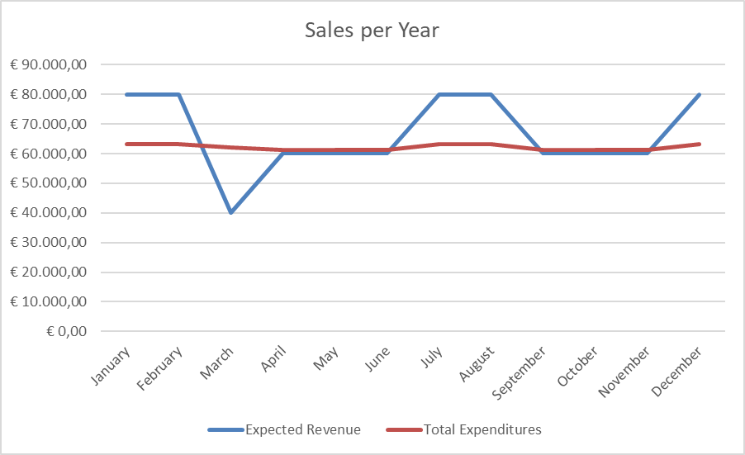

Production Process and Machinery
A survival Package consists of three components. One bag for heating the meal, one that consists a small amount of water and the actual meal-bag itself. Our Meals must be prepared in sterile rooms to ensure the long shelf life. In our cooking station the different ingredients get pre-cooked and prepared. All ingredients are cooked separately to the point. Only then can the water be extracted from them in special drying plants. Sensitive and high-quality ingredients (meat, vegetables, cheese, etc.) migrate into a freeze dryer, which works very gently. Spices, herbs but also oils and fats are spray-dried. The process is so sophisticated that almost all nutrients are preserved during processing. The long shelf life of 15 months on average is due the fact that germs and bacteria cannot exist without water.
Most of the vegetables, meat and fish will be bought if it is possible from regional farms or regional traders (for example from EFKO, obst-samhaber or Fleischerei Lackinger ).
After that the precooked ingredients are put in big boilers. There the different menus are getting cooked together and additional minerals, vitamins and electrolytes are added to the food. These menus are for example Chicken Curry with Rice, Barbecue Pork with potatoes, Paella and Spaghetti Bolognese. After that the ready to eat meal is pumped to the filling station. There the recyclable packages will be filled one after the other. Then the imprint with the expire date, an instruction how to use the package and what meal is inside are put on the bags. The bags are pumped up by air-pressure and filled with the same amount of food. Before the bag can be closed, the top edge must be cleaned. After top edge of the bag can be sealed and welded together.

The Flameless Ration Heater
Flameless Ration Heater is a water-activated and environmentally friendly heater. It is especially designed for the Army to heat a soldier’s individual Meal, Combat ration from FSC.
That heater heats food without the need of fire very quickly. That heater can be used easily in situations where fire is prohibited or not recommended. It is ideal for soldiers in the fields, campers, hunters, boaters or anyone interested in emergency preparedness. A heater is very small and light. (15 cm long x 12cm wide and 4cm thick)
How to use the heater: You have to cut open the top of the bag sleeve, place the food portion inside the bag next to the heater and add plain water. In just 10 minutes the food ration is ready to eat. Spent pads are easily disposed, with no toxic materials. The heater is made from powdered food grade iron, magnesium, and sodium.

Machines
Zubereitungstisch mit Umluftventilator Modell SH 200
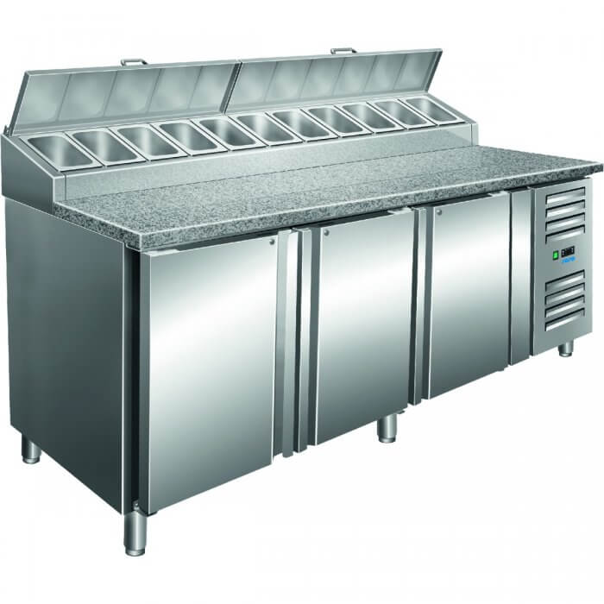
Kombidämpfer ME 1.20 BDI Roll-in
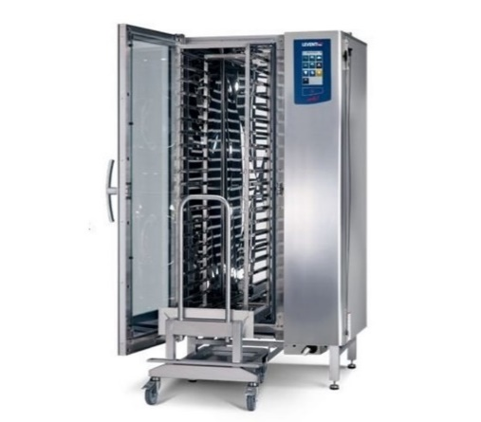
Gas-Kochkessel
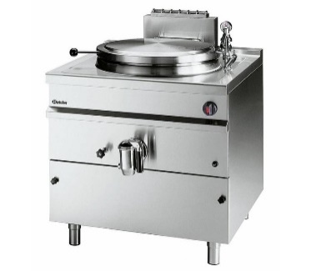
AEROTEC pneumatic boiler 1000 L
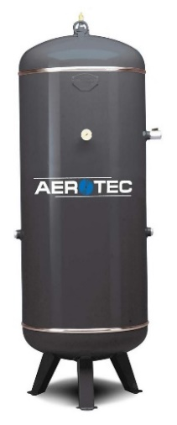
Cooling-cell PROFI 80
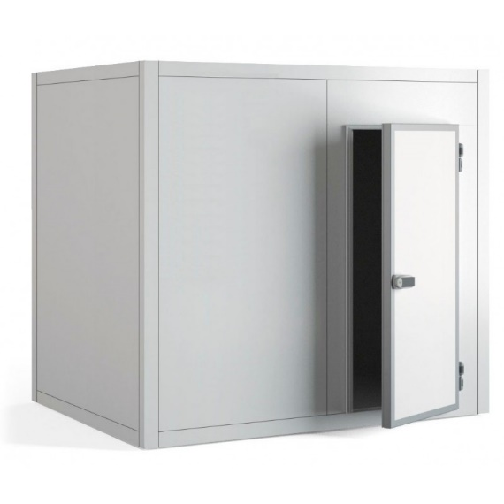
Conveyor Belt
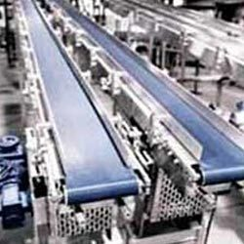

Factory
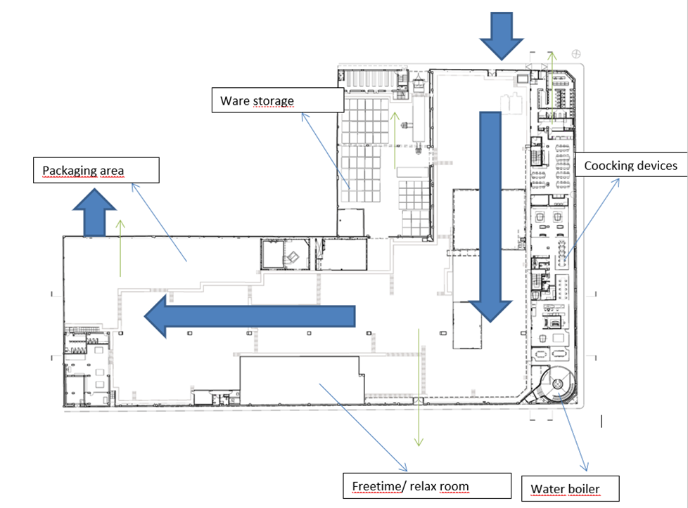

SWOT analysis
Strengths | Weaknesses | Opportunities | Threats
Uniqueness:  Alternative to other ready to eat food (heating system with water) | Lack of reputation:  Although the business already existed in the past for some decades the company is not very well known | Target market growth: More people/families go out into the nature for hiking, mountaineering or camping many new customers | Competition: Already existing companies have loyal customers
Management:  Wide ranging expertise (experts from military, sports and health/nutrition) | Lack of capital: Startup funds from loans. Own invested money | Military: The countries in the EU are building up their armed forces. Because of that good and easy nutrition is needed | Opening day issues: Customers might not return
Location:  City with direct connection to the highway/train and to the Danube (perfect for transporting the products) | Production costs: high costs because of high personnel expense | Easy warm up system: blend the meal with water and the product is ready to eat in just a few minutes (without gas cooker) | Costs: Rising costs of personnel and also of the ingredients
Unique taste of our products and the perfect quality of our food | Quick expansion: There are a lot of new hires to train and organizational structures to learn | Gluten-free/ vegetarian/vegan social trend: Different products are available for every lifestyle | Local, national and international competition

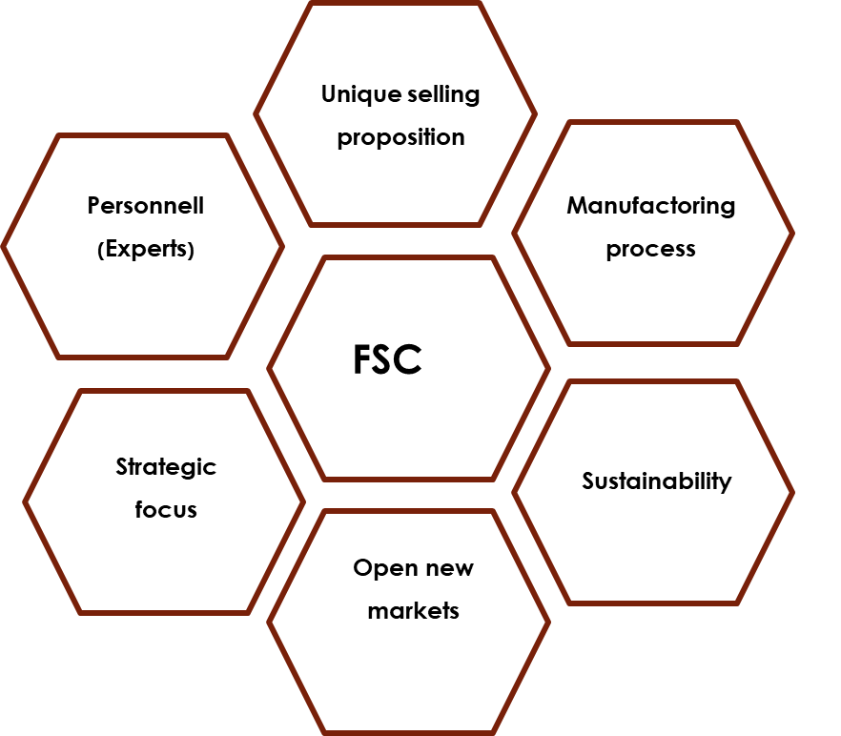

In the attachment
There we would list our CVs, Personal certificates, Patents and Contracts as well as the Market search.

