Heimdalls Hall - Army Shop

Business Plan

Created
From March to May 2022
at the
Moravian Business College Olomouc

Instructor/Lecturer:
doc. Ing. Adam Pawliczek, Ph.D.

Author:
Daniel Binner and Benjamin Daud

Team Members:

Team Member 1: Daniel BINNER
23 years old
Male
Business license
Military experience

Team Member 2: Benjamin Daud
27 years old
Male
Business licence
Military experience

Product/Price:

- Products for military usage/(civilian usage)
- Manufacturer’s suggested retail price, discount for public servants
- Prototype: e. g. Black Shadow

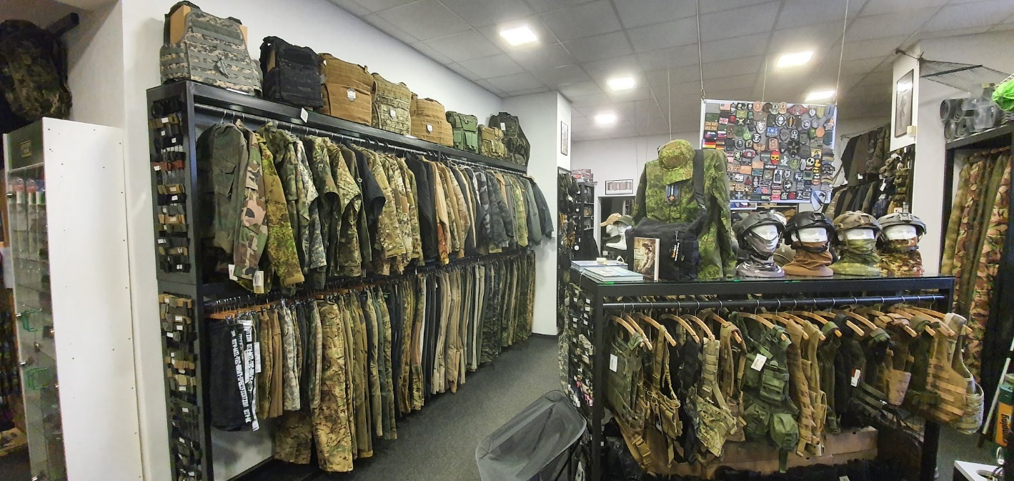

Market:
- Destination group: Military, Police, Survival (Huntsman), Civilians, Hikers
- Competition: Black Shadow, Steinadler, Hunting stores

Financial Demanding of the Project:
- Costs: Store rent, furniture, goods carriers, cash desk, product basic configuration, insurances, promotion

Our Deposit (Effort, Time, Know-How, Own Investment):
- Effort: 300 000€; Credit 200 000€
- Time: Full time
- Know-How: Yes; military background, business economics
- Own investment: Initial capital: 100 000

Time demanding:
- Approximately 6 – 12 months
- First insight: detailed planning for one year before start

Contract Information:
- Limited liability company

Disclaimer/Responsibility Refusal:
- Limited liability company
- Stuck on the credit
Proposal to the investor:
- Not necessarily self-investment (founding of a limited liability company around 100 000€)
- Credit for the rest

Characteristics of Proposer:
- Heimdall‘s Hall Army Shop
Burgplatz 1, Wr. Neustadt
Heimdall-armyshop@gmail.com

Company description:
- Legal Form: Limited liability company
- History: Just started
- Business license, military background/Know how

Work Team:
- Daniel BINNER & Benjamin DAUD
- 23 & 27 years old
- Team player

Management:
- Structure: Flat Structure, two bosses, three employees
- Responsibility: BINNER: Quality Management and PR
DAUD: Business and Finance, Sales and distribution

Vision and Mission:
- Vision: To sell products everywhere in Austria
- Mission: To be the top seller of our products in the region

Project strategic goals statement (SMART):
“Grow the number of monthly customers by 200 within Q1 of 2023. This will be accomplished by optimizing our online store and creating targeted social media campaigns, which will begin running in November 2022 on three social media platforms: Facebook, Instagram and TikTok. Since online sales are our main focus, optimizing our website and the social media campaign will increase sales.”

Aiming and prime activities of the project:
- Opening of our saleroom/shop
- Storage
- The online going of our website
- Contract with suppliers

Product description (prototype) and contribution (added value) for costumer:
- Clothing for military purpose (uniforms, Battle Vest) and civilian purpose (Clothing with camouflage template)
- Weapon tools (Knives, opticals, binoculars, Weapon Accessories, Pistols and Rifles, Hunting Weapons)
- Boots (Hiking, Military, Police)
- Merchandise
- Survival equipment
- Ammunition: Cat A and Cat B

Profitability of the product (Market estimation):
- Weapons: List price, estimated 10-30%
- Clothing/Shoes/Survival: 100-200%
- Merchandise: 200-400%
- Ammunition: List price, estimated 5-10%

Recent product conditions, development phases, IP rights (Patent):
- Weapon Conditions: Cat A: 18years, Cat B: Weapon license. No selling of Cat C Weapon
- No selling of Weapons on the day the weapon is ordered to prevent assaults. (3 days)
- Knives: Pocket knives 16 years, Hunter knives 18 years
- Weapon tools: 18 years
- Ammunition: 18 years

Product with the greatest demand:
- Survival and hunting (camping, knives and tents)
- Shoes (Army, police and hiking)
- Weapons (Hunting and small arms)
Market Research and Analyses

Political and legislative factors:
Work time:
Normal working hours for full-time employees are 40 hours. Part-time employees work fewer hours. They receive - converted to the working hours - the same remuneration as full-time employees. Normal working hours may be exceeded by overtime. 12 hours per day, 60 hours per week may be worked.

Employees must observe working hours, rest breaks and daily rest periods. There are special regulations for night work and for drivers.

Normal working hours
Normal working hours are 8 hours per day and 40 hours per week. These are pure working hours without rest breaks. If the daily or weekly normal working hours are exceeded, the employee generally works overtime. On a case-by-case basis, up to 12 hours per day and 60 hours per week may be worked - but permanently no more than 48 hours per week on a four-month average.

In the case of a four-day week, the normal daily working time may be extended to 10 hours.

An extension of normal working hours is possible within the framework of various flexible working time models. Models of flexible working time include, for example, the calculation of working time or flexible working time. The details of flexible working time models can be found in various collective agreements. However, a number of collective agreements provide for a reduction in the statutory normal working week.

There are various differences in the structure of flexible working hours in the individual sectors, for example, in crafts and trades, commerce, services in automatic data processing, iron and metal processing (white- and blue-collar workers), hotels and restaurants, or in the flexible working hours in the collective agreement for white-collar workers in information and consulting. In the monument, facade and building cleaning sector, there is the "flexible working time bandwidth" model.
Hiring employees:
Job advertisements must contain information on the minimum wage. Applicants may charge travel and accommodation expenses to the employer in certain cases. The probationary period for newly hired workers may not exceed one month. The employer must issue a service slip for each new employee and register them with the tax and social security authorities. The Labour Market Service promotes the qualification of workers and the hiring of the first employee. Older workers are to be kept in employment longer.

Salary:
Remuneration is any kind of consideration that the employee receives from the employer for making his or her labour available to the employer. Rights and obligations are specified on the service slip or in the written employment contract.

Remuneration includes:
the regular remuneration (in the case of salaried employees, the monthly salary; in the case of workers, the weekly or monthly wage)
all other regularly or irregularly granted cash benefits, e.g. special payments such as anniversary bonuses (with regulations under labor law and social law), revenue shares and commissions
all other regular or irregular benefits in kind, e.g. free parking spaces, company housing or private use of a company car.
Most employment relationships are governed by collective agreements that stipulate minimum salaries or minimum wages as the lower limit of permissible remuneration. The possible entitlement of the employee to a Christmas bonus (Christmas bonus) is also regulated there. An entitlement to a vacation allowance (vacation bonus) also only exists if this is provided for in the collective agreement or the individual employment contract.

Tax policy: Value added tax(VAT)
VAT is not only payable on the supply of goods and services. It also applies to own consumption and imports of goods from third countries or the EU. It is withheld at every stage of the economy (e.g. at the producer, wholesaler and retailer). Entrepreneurs must calculate it and pay it to the tax office. There are special provisions, e.g. for renting and leasing of real estate as well as sales of real estate.

The standard tax rate is 20 %. For certain transactions, such as food or accommodation, the reduced VAT rates of 10 or 13 % apply.

There are tax exemptions for certain transactions. A distinction is made between genuine exemptions, e.g. for exports to third countries, and non-genuine exemptions, e.g. for insurance, renting business premises or the small business regulation. Small entrepreneurs do not have to pay sales tax, but they also cannot use the input tax deduction. They may not exceed the turnover limit of 30,000 euros net per year.

Foreign trade regulations:
If a foreign company makes a delivery in Austria and the recipient is an entrepreneur or a legal entity under public law, the so-called deduction procedure should be applied.

Effects of the deduction procedure on the foreign supplier

The foreign entrepreneur must submit an invoice for the delivery with Austrian VAT, unless a tax exemption applies in the individual case. For this purpose, the foreign entrepreneur must register with the Graz City Tax Office for VAT purposes.

Effects of the deduction procedure on the Austrian recipient

The Austrian recipient must withhold the VAT and pay it in the name and for the account of the foreign entrepreneur to the latter's tax account at the Austrian Tax Office Graz-City. Recipients entitled to deduct input tax may claim the sales tax transferred to the Austrian tax office as input tax.

Technical norms and regulations:
There are three categories of firearms:

Category A: Prohibited weapons and war material.
Category A prohibited weapons include, for example:

Shotguns (shotguns) with an overall length of less than 90 cm.
Shotguns with a barrel length of less than 45 cm
Fore-end repeating shotguns ("pump guns")
Camouflaged firearms (e.g., "shooting ballpoint pen")
Prohibited cutting weapons, such as brass knuckles, manslayers and steel rods
Centerfire handguns with a magazine (integral or attached) capable of holding more than 20 rounds of ammunition
Semi-automatic rifles with centerfire ignition with magazine (integrated or attached) that can hold more than 10 cartridges
Magazines for centerfire handguns that can hold more than 20 cartridges
Magazines for semi-automatic rifles with centerfire ignition that can hold more than 10 cartridges
Category B: Handguns, repeating shotguns and semi-automatic firearms.
Category B firearms are handguns (revolvers, pistols), bolt action shotguns, and semi-automatic firearms that are not war material or prohibited weapons.

Category C: firearms with rifled or smooth-bore barrels, unless category A or B.
Rifles with at least one rifled barrel that must be manually reloaded after each shot fired
Rifles with smoothbore barrels only, which must be manually reloaded after each firing.
Deviating from this are: Fore-end repeating shotgun ("pump shotgun") = category A and repeating shotgun = category B.

Ammunition for handguns with centerfire ignition or with a caliber of 6.35 mm and above may only be provided to, and acquired and possessed by, holders of a firearms pass or firearms possession card.

Ammunition may also be provided to, and acquired and possessed by, holders of a registration certificate for a category C firearm if the ammunition is suitable for the firearm specified in the registration certificate.
Requirements:
- Completed 18th year of life
- Registration of the firearm in the Central Weapons Register by the firearms dealer

Socio-cultural factors:

Demographic population trends:

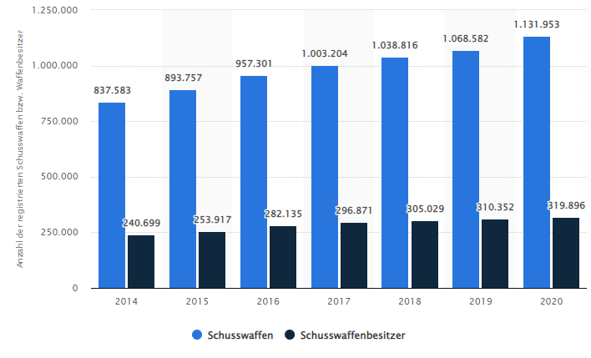
This chart shows that the number of firearm owners is steadily increasing. However, it is interesting to note that the number of firearms per owner is increasing even more. Migration, war in Europe and declining trust in politics reinforce the effect.

Economic factors:

Inflation: As is true for any business, when inflation rises, less is consumed. This leads to a drop in sales.

Currency exchange rates: exchange rates have a massive impact on the import and export ratio. Especially in the arms business, which is very dependent on imports from other countries, a stable exchange rate is very important.

5 forces analysis:

Forces | Explanation | Evaluation
Competitive surrounding | Within the radius of 50 km: Three shops that offer similar products. | -
New substitutes | We stand out because our range of products is wider than the competition and therefore appeals to more potential customers. | +
New competitors | none | +
Suppliers | three to four international suppliers and up to 5 domestic suppliers. Due to the economic advantages offered by the EU, most foreign suppliers come from Europe. | ~
Customers | We address more target groups than our competitors. Due to the large number of barracks, police schools, the military academy as well as large hunting grounds, we have a larger customer base. We offer civilian as well as products for emergency organizations. | ++

Technologic factors:

Webshop:
Search bar
Own profile

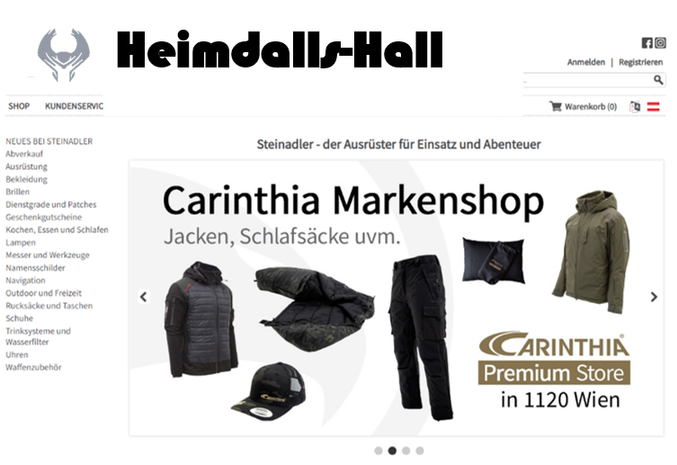
Categories
Special offers/advertisement
Technological products:

Hanwag Yukon:

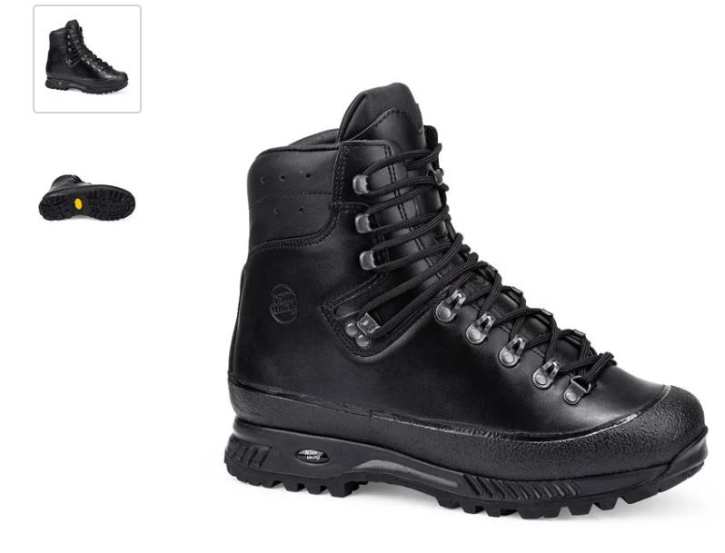

PRODUCT DESCRIPTION
The Yukon is a trekking boot that will go virtually anywhere. The higher upper provides enhanced protection for the sensitive ankle zone on longer day hikes or multi-day trekking trips. Underfoot, the cushioning Vibram® sole provides additional stability, plus reliable grip on rock, scree and root-strewn trails. Inside, the comfortable leather lining ensures a pleasant foot climate.

MATERIAL SPECIFICATION
Upper material: Nubuck leather
Outer sole: Vibram® Fuora
Lining: Leather
TECHNICAL DETAILS
Weight: 1620 g
Weight reference: one pair size 8
Lace length: UK 6 - 8 = 190cm | UK 8,5 - 11 = 200cm | UK 11,5 - 14 = 210cm
Field of Application: Trekking, Hunting
Cut: High

Tent: “The Cave”

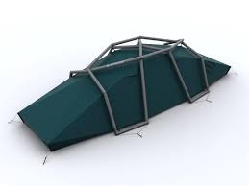
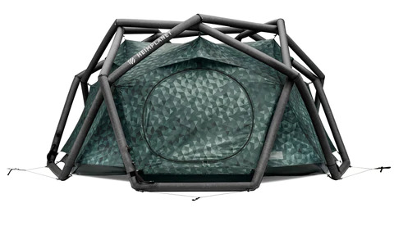

Designed for 2-3 people, the inflatable tent "The Cave" from Heimplanet offers very good stability thanks to the geodesic dome construction. In addition, the "Cave" is weatherproof, durable and offers enough storage space for smaller and larger items with the sewn-in pockets inside the tent.

The technical data of "The Cave":

- Weight: 4.8 kg
- Pack size: 40 x 32 x 23 cm
- Inner tent height: 102 cm
- Total height: 127 cm
- Material: Frame: Recyclable material, fly: extra stiff and durable polyester, inner tent: flexible thermoplastic polyurethane, fly: 100% ripstop polyester, inner tent: 100% nylon
- Water column: 5.000 mm
- One-pump system
- Five closable ventilation points
- Several inner compartments
- Included in delivery: pegs, repair kit, guy ropes, stuff sack, gear loft, pump adapter
- No pump included
- Price: 699 Euro

Walther Q5 MATCH Champion:

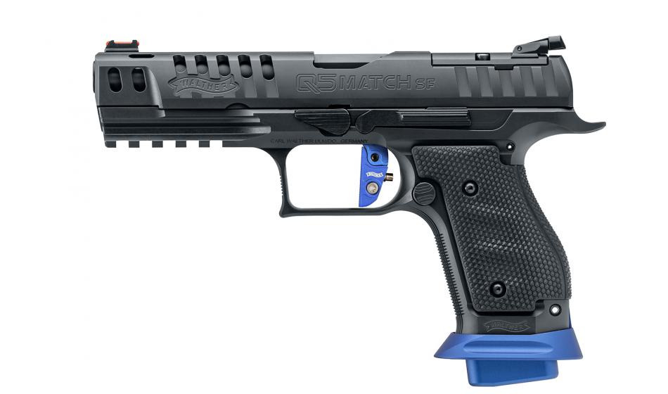

Design as Q5 Match, but:

- "Dry" trigger due to adjustable sear overlap.
- Extra heavy tungsten recoil spring rod
- Three 17-round magazines

Technical data:

- Caliber: 9x19mm
- Magazine capacity: 17 rounds
- Three autamatic safeties
- Three interchangeable grip backs
- Trigger: Quick Defense, preloaded
- Trigger weight: 2500 g
- Distance from trigger to grip back: 72 mm
- Distance barrel bore axis to shooting hand: 25 mm
- Sight: adjustable metal rear sight, front sight with red fiber inlay
- Sight length: 181 mm
- Barrel profile: polygon
- Barrel length: 127mm/5"
- Dimension (L/H/B): 206/137/34 mm
- Weight: 775 g
Project Marketing Proposal

Number of Employees: 2+3
3 Employees in the beginning. 2 in the Shop, 1 for warehouse and online orders.

Expected Qualifications of Employees:
- Rules and Regulations for buying Weapons in Austria
- Experience in Sale
- Social Media awareness & experience

Job Description:
Employee Shop Wiener Neustadt
(30h | from May 2022)

We are a retail company with location in Wiener Neustadt. Our business field is a niche in the outdoor and military sector, which we fill very well as one of the largest suppliers in our industry.

For our location in Wr. Neustadt we are looking for a person who is interested in our products, dealing with our customers and selling.

What is it about:
- Personal and telephone customer service
- Product consulting and sales processing
- Order processing
- Answering written and telephone customer inquiries
- Inventory management and shelf management
- Cash register management

What we expect:
- Interest in our products - experience is an advantage
- high level of organizational skills
- solution-oriented thinking and independent action
- customer-oriented, communicative appearance
What we offer:
- participation in a young company
- imaginative, independent and dynamic team
- KV minimum gross salary at 38,5h/week: EUR 1.800 | readiness for overpayment is available

If you are the right person for us, we look forward to receiving your application including
- curriculum vitae
- current photo
by e-mail to Mr. Daud: job@heimdallsarmyshop.com
Personal Agencies: None

Ways and Costs of Promotion (Internet, FB….):
- Internet 30€/Month
- Promotion 500€/Month

Ways and Costs of Distribution:
- Packings 5-10€/order domestic country. 15-20€ foreign country
- B2C: We dont sale to other companies
- Shop: 1500€

Margin and Product Price:
- Weapons: List price, estimated 10-30%
- Clothing/Shoes/Survival: 100-200%
- Merchandise: 200-400%
- Ammunition: List price, estimated 5-10%

Definition of Goals and Milestones of Success in Time:

Goals before Shop opening
- Opening of our Saleroom/Shop in 12/2022
- Storage 09/2022
- The online going of our website 12/2022
- Contract with Suppliers 06/2022
Goal for the next year:

Grow the number of monthly customers by 200 within Q1 of 2023. This will be accomplished by optimizing our online store and creating targeted social media campaigns, which will begin running in November 2022 on three social media platforms: Facebook, Instagram and TikTok. Since online sales are our main focus, optimizing our website and the social media campaign will increase sales.

Financial Analysis:

Operation costs:

Description | Cost (€)
Rent  Furniture & Equipment  Electrical installation  Salaries and wages  Advertisement  Insurance  Purchases | 1500/month = 18000/year  45 000  5000  ~10 000/month for 5 people = 120 000/year  500/month=6000/year  500/month=6000/year  100 000/year
Total | 300 000€

Starting cash:

Sources | Euro
Personal savings  Bank loan | 100 000  200 000
Total | 300 000

Estimated cash sale in the first year: 250 000€
Cash flow= Cash sale - Expenditures
Cash flow: 250 000€ – 300 000€ = - 50 000€

Estimated positive Cash flow in the second year

Break Even Analysis:

Description | Euro
Sales | 250 000
Rent  Salaries and wages  Advertisement  Insurance  Purchases | 1500/month = 18000/year  ~10 000/month for 5 people = 120 000/year  500/month=6000/year  500/month=6000/year  100 000/year
Total variable cost | 250 000

Break Even point is reached in the second year.

